[insert organization logo, delete this text box.]

LOST DOG PREVENTION AND PROCEDURES

We get it, dogs can get loose even if we do everything right. However, in most cases, a dog becoming loose can be prevented. The guide below includes dog security policies compiled from our decades of experience to help you avoid losing your foster dog. Should your foster dog become loose, DO NOT CHASE and do step 1 below. CONTACT [insert contact] IMMEDIATELY (NOT after chasing the dog for a mile).

Prevention
STEP 1 IN LOST/LOOSE DOGS IS PREVENTION.
Especially in the first few days to a week with your foster dog:
- DO NOT ASSUME YOUR FOSTER DOG IS LIKE YOUR PREVIOUS DOGS OR FOSTERS OR FRIENDS’ DOGS. These dogs may have unknown pasts and learning histories. Assume your foster dog will always take off.
- Use a properly fitted martingale (limited slip) collar ALWAYS. This can be attached to a harness if you prefer using a harness. Speak with [insert contact] on how to do this or prior to using different equipment on your foster dog.
- NEVER, EVER let your foster off the leash in an unfenced area.
- If you have a 5 foot fence or less, attach a long line to your foster dog for yard time until you and your foster coordinator are sure they will not jump the fence.
  - If your foster has a history of jumping/climbing fences or the organization requests it, your foster must be attached to a long line at all times.
  - Check all gates prior to letting your foster out to the yard.
- Do not open doors around your foster dog. Speak to your children about this. Put your foster on a leash or put them in a gated or closed door room or their crate before opening any doors at any time for any reason. This applies to cars too – crate your foster in the car or tie their leash to a headrest. Reach out to determine other safety measures relating to opening doors around your foster if you are not sure. Crate or leash your dog when visitors are visiting as they are likely not aware of door safety with your foster dog.
  - If you have a garage door, get in the habit of keeping the garage door closed or keep two layers of interior doors leading to the garage closed.
- Ensure you are able to hold on to your dog’s leash. This includes assuming that your foster could lunge or jolt on leash anytime, taking your off guard. Do not walk your dog in icy conditions to prevent slipping and dropping the leash. Walk your foster in quiet areas so they do not become startled and bolt, pulling the leash out of your hands. See images at bottom.
  - It is not advised to use a retractable leash with your foster dog. If the leash is dropped, the handle dropping to the ground can startle your foster dog and scare them into running away.
- Children under 13 years should NEVER walk a foster dog. Children over 13 years should be intensely supervised by an adult right next to them while walking a foster dog, using a second leash or slip lead that the adult holds on to for several walks until you are sure the children can safely walk the dog (younger children can participate in leash walking using this method). No children under 18 years of age should walk a dog over 40 lbs without an adult holding a second leash for any reason unless approved by your foster coordinator.
- If you visit a friend’s house with your foster dog, your foster must remain on leash held by you or another adult in your family at all times unless approved by the organization.
- Any dog walkers you enlist to help with your foster dog must be approved by the organization and the organization must speak with them prior to their first session.

Additional Resources for Dog Handling:
https://www.youtube.com/watch?v=R5aKUrPLkco

Loose/Lost Dog Procedure
DO NOT CHASE YOUR FOSTER DOG. YOU WILL NOT CATCH THEM. THIS PUTS DOGS INTO A STATE OF FEAR AND MAKES THEM HARDER TO LURE AS WELL AS PUSHES THEM FURTHER FROM THE LOST LOCATION. DO NOT CALL FOR A SEARCH PARTY! Only 1-2 people should search one area together. Too many people can scare even a friendly dog. Do not be shouting your foster dog’s name at any point in the search! Most fosters do not truly know their name especially when they are loose.
You are expected to have a sense of urgency and responsibility to help until the dog is found if you lose your foster dog regardless of the reason.

- If your foster is still in view:
  - If you are able grab high value (human) food within seconds, get it, but don’t waste time and lose sight of your foster dog. You may also want to prioritize getting a slip lead or leash when your foster gets loose so you have something to secure to them. You may have someone else get these items for you.
  - Make kissy noises, talk baby talk, while standing in one place.
  - Softly jump and bounce then RUN in the OPPOSITE direction of your foster dog to invite the dog to chase YOU and engage in play.
  - If the above work to get your foster interested in you and they begin to approach – the most important thing is to NOT immediately try to grab them; you likely will not be successful.
  - Continue to engage with your foster dog by having them continue to chase you or sit on the ground and invite them over to your lap (do NOT reach for them).
  - If you have food, sit and throw high value (human) food at your foster dog, throwing it closer to the dog then closer to you as they approach. Don’t make your foster come to your hand for the food. Be generous, keep them engaged.
  - If your foster dog is lured in with these tricks and jumps on you repeatedly or lays in your lap or eats the food you drop, keep the process going for at least 30 seconds so they do not suspect you will grab them. If they are dragging a leash, step solidly on the leash and pick it up. If not, strategically grab their collar and twist (this is to ensure it does not pop off their head) or grab their entire body if small or no collar and large. If you do not do this step successfully and your foster gets loose again, it will be much harder to lure them in again. Be swift, be smart.

- Contact [insert contact] and provide the specific location your foster was last seen. Follow any instructions given.

- Contact your police department’s local number and inform them your foster dog is loose. Provide a basic description (size/color/gender/any collar or harness), last location seen/lost from, and your phone number (provide the foster coordinator’s number too). Advise the police NOT TO CHASE the dog and just call you or your coordinator if the dog is spotted as the dog is most likely to approach you as the foster home.

- At a walking speed, walk for 5 minutes in the direction you think they traveled and see if you can spot them. Refer to step 1.

- Get in your car, drive for 5 minutes in the direction you think they traveled and see if you can spot them. Refer to step 1.

- If possible, fire up your grill and throw any meat-type food and copious marinade on the grill and let it cook. The aroma can draw your dog back to your location. If this is not possible, quickly stove or microwave warm a meat-type food product and set the food in a safe location away from busy roads near the lost site. If neither is possible, use fast food burgers or wet dog food; dry food or dog treats usually will not work.

- After this point, work with [insert contact within the shelter/rescue] to determine next steps pending several factors; i.e. where your foster was lost from, the situation in which they became lost, if there have been any sightings, and your foster’s personality and likelihood to hide or approach a human or other dog. Potential next steps may include:
- Posting on social media in community groups and lost dog groups. Do not post your lost dog on any social media unless otherwise directed.
- Adding a picture to the lost dog flyer template and printing posters for posting and distribution.
- Post flyers on telephone poles using a staple gun, tape, or zip ties.
- Procuring and setting an automatic animal trap with food bait
- Procuring and setting up a trail camera (like for hunting) for sightings and to confirm dog’s location (these cameras are real-time and motion activated, taking snap shots of any activity).

Loose Dog Contact
If your foster becomes loose CONTACT [insert contact] IMMEDIATELY (contact the additional contact right away if the first contact does answer). DO NOT CHASE A LOOSE DOG.
Lost Dog Contact: Name: _____________________________ Phone: __________________________
Additional Contact: Name: _____________________________ Phone: __________________________

Martingale (Limited Slip) Collar
May have a chain section. The leash always goes on the outside loop ring.
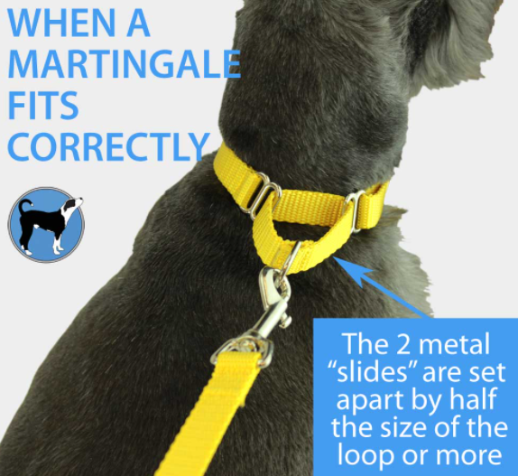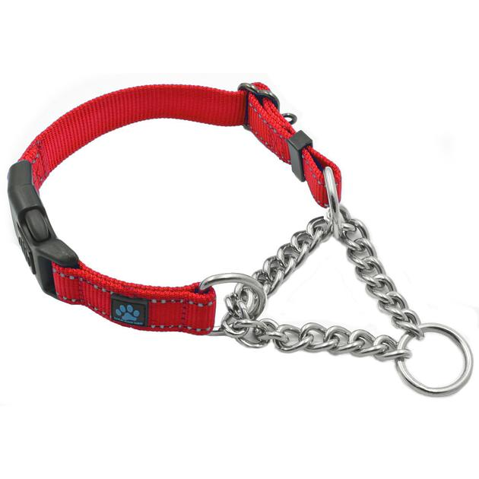

Best way to hold a leash

1. Drape leash over thumb 2. Put hand through handle 3. Grab all 3 leash pieces in fist
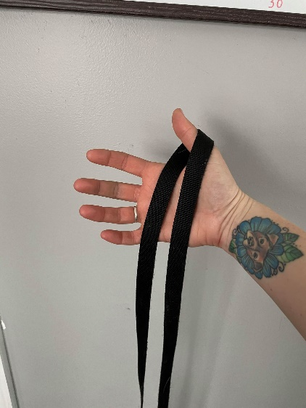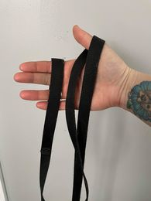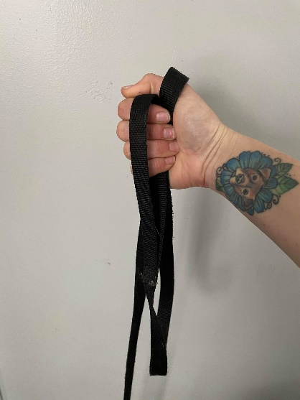

Turn a Leash into a Slip Lead by Putting the Clip Through the Handle

