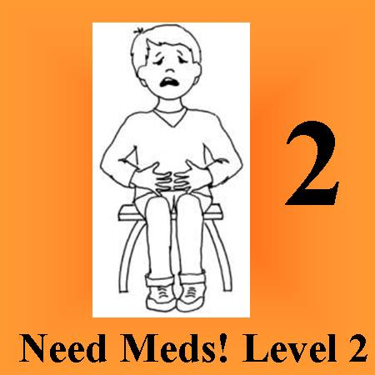 Rx: To reduce family stress and improve pain management understanding.
Order: My Pain Alert ™ Scale Communication Tool
ISBN 978-0-9981610-0-6 Print - $7.99 also E-pub or Kindle - $2.99
From your favorite bookseller one month before hospitalization is scheduled to allow learning time.
This 36 page paperback book:
Is easy to understand, and appropriate for very young children.
Is age neutral, accommodating neurological, sensory, and autism issues.
Teaches FDA approved methods of pain medication use.
Provides “as it happens” pain history recording system which can be stored on parent/caregiver cellphone.
Includes 0-5 level pain scale suitable for everyday use. My Pain Alert Scale also adapts for special populations using pictures and toys to define the levels.
For more information go to: www.mypainalert.com
An online book review will help others learn about this tool.

