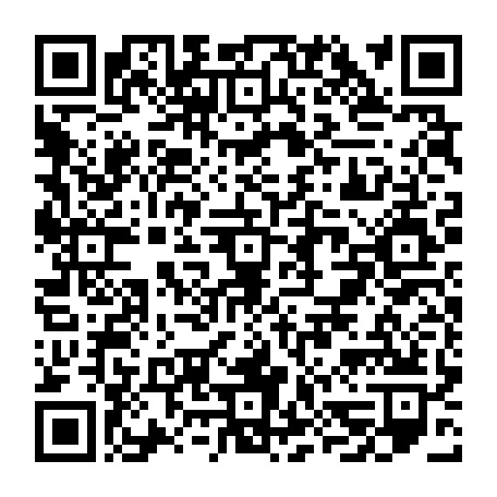

BrainTap for Firefighter Wellness

Firefighters ramp up quickly- the challenge is coming back down. BrainTap helps
your nervous system shift into recovery so you can sleep better, reduce stress,
and improve regulation.
What It Helps With
Relaxation after difficult calls
Better sleep after interruptions
Reduced anxiety and mental overactivity
Improved emotional regulation at work and home
How It Works
Guided audio, light stimulation, and breathing cues help your brain shift into a
relaxed state. Sessions typically last 10–20 minutes. Use on or off shift, after calls,
before bed, transition from work mode to home, or anytime you need to reset.
Daily practice improves sleep, stress, and recovery.
Scan to request a BrainTap Headset through The 100 Club Peer
Modalities

