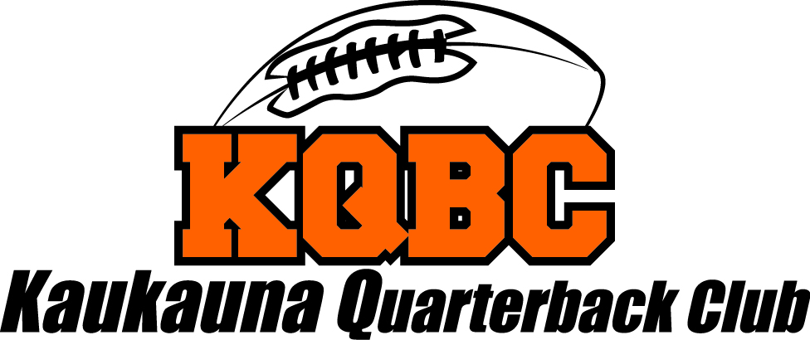

# Meeting Minutes

# May 19, 2021

# 7:00PM meeting called to order by President Heather Steineke.

# Meeting minutes from April 12, 2021 were uploaded to website. No corrections; minutes approved.

# Attendance:

1. **Coaches Update** – Matt Binsfeld
   1. Coaches meeting last week for all conference coaches. Green Bay SW is all set. Added a JV game with GBSW.
   2. Thank you to all that helped with Parent Meeting. Went well. 100/120 parents in attendance. Those not in attendance were emailed information.
   3. We did get some All-Conference awards awarded to some players.
   4. Ben Moore & Logan Fitzhugh have been elected to All-Star Game. Quick turnaround this year due to having spring football season. Club will be asked to donate to their fundraiser at next meeting. Game is July 17th 5:00PM at Titan Stadium. **Motion made by Kim Ryan to donate $300 to each player. Second by Lisa Natrop.**
   5. Brennan Kuske- 1st Team All-State, Ben Moore & Gavin Lahm – Honorable Mention. All State Banquet in June that Brennan and parent’s will attend. They will be asking for club to support an ad in the banquet booklet. **Motion made by Rick to donate $300 to Brennan for the half-page ad in the banquet booklet. Second by Lisa Natrop.**
   6. 370 kids signed up for summer school. We will be getting 2 more racks added to the weight room. Currently have 10 racks – 3 kids per side. Needed more to accommodate the number of kids coming through the weight room.
   7. Freshman signing day is this Sunday, May 23rd. Michelle will take pictures. Anyone who would like to be there is welcome. Expecting about 30 players to attend and get matched with a senior mentor. Open gym afterwards.
   8. Raiders parent meeting last Sunday. Have about 120 kids. 50% attendance at parent meeting. 7th & 8th grade teams look good with numbers. 6th grade teams will have only about 35 kids. Looking for more kids for 6th grade team.
   9. Apparel order extended through May 24th. The 2 out of stock items should be back in stock on Friday. Coach will send another email out to everyone.
2. **Financial Report** – Amy Bartel
   1. See attached report.
   2. Kwik Trip, mask money collected
   3. Rick has taken care of getting Cushman serviced.
   4. Kwik Trip cards are available – great gifts for graduations!
3. **President’s Update** – Heather Steineke
4. **Golf Outing** – Elliott Nytes
   1. We only have 2 meetings until outing.
   2. Elliott will be golfing day of and will need help the day of. Would like someone to take over heading help the day of.
      1. Hole In One – Pleshek sponsor (Rick will talk to Pleshek)
         1. Rob/Jane Eiting – betting hole
      2. Rob Eiting had idea of a raffle for day of – less hole games and allows golfers to golf.
      3. Putting Green game
      4. 50/50 table
      5. Bra Hole
      6. Booze Wagon – Pop In will donate some bottles.
   3. Elliott will take care of all golfing correspondence/sponsorships/awards.
      1. One team sign up so far.
      2. Looking for gift card donation primarily.
      3. Will be awarding 1st, 10th and last place golf teams.
      4. Eagle Graphics will donate can coozies for the golf carts. Need someone to coordinate goody bags. Kim Ryan & Brenda Ernest will work this.
      5. Need volunteer coordinator for day of. Lisa Natrop will do this.
      6. Need registration table workers – Brenda Ernest & Kim Ryan will work this.
      7. Need booze wagon workers.
      8. Will discuss outing in more depth after June 9th meeting for anyone willing to help.
5. **New Business:**
   1. Meeting minutes are now available on GhostsFootball.com website. Click on “KQBC” and 12 months of meeting minutes are available.
   2. Rick, Jane & Lisa met to go over By-Laws. 2 small changes requested to be made is:
      1. Membership: update to lifetime membership for one-time payment. **Motion made by Kim Ryan to make the requested updates to the bylaws. Second by Brenda Ernest.**
      2. Voting: present at 2 meetings within the last 12 months in order to vote.

**Motion made by Rick Balck to make the requested updates to the bylaws. Second by Bob Wurdinger.**

* 1. Rick Balck had Merle Reis fix table top in concession stand at Bayorgeon Field. Cost was $300. Decision was made to ask Raiders to pay for that.
  2. Concession Stand at HS – will likely not know if we can have concession stand open until July. Rick Balck will reach out to Chris McDaniel to find out if it will be allowed so that we can get volunteers signed up. Coach will also be looking for Raider family members to volunteer for Raiders concession stand. Also, will need to add 50/50 volunteers to the volunteer list.

**Next monthly meeting will be held:**

June 9, 2021

Cash ‘n Swillies

7:57PM meeting adjourned.