WVAS Candidate for Vice-President

Bob Custard, REHS, CP-FS, CPO-I

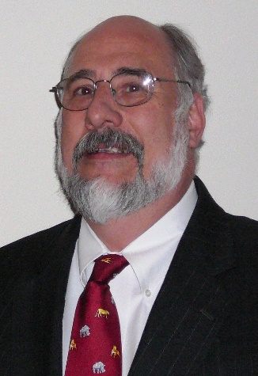

In 2018, Bob began working to stabilize the environmental health program in Jefferson County, West Virginia, after they lost all four of their sanitarians. Under his leadership they have rebuilt the EH program there and have begun working to meet the Voluntary National Retail Food Regulatory Program Standards. They have qualified for more than $300,000 in EH grants and four student interns from FDA and CDC through NEHA, AFDO, and NACCHO.

Previously, for 28 years (1987-2014), Bob served as an environmental health professional at the state and local levels in Virginia. For the thirteen years prior to his retirement from the Virginia Department of Health, Bob was the Environmental Health Manager for the City of Alexandria. Before that, Bob coordinated Virginia’s statewide environmental health training program for ten years.

In 2015, Bob created Environmental Health Leadership Partners, a consulting firm specializing in environmental health leadership development and management. As a consultant, Bob has facilitated training courses, evaluated environmental health programs, and represented national organizations at professional conferences. Bob is passionate about mentoring emerging environmental health leaders. He was a driving force behind the creation and development of NEHA’s Environmental Health Leadership Academy.

Bob has made six trips to Africa and one trip to Romania to assist various charitable organizations with improving drinking water quality. In 2010, Bob and his wife, Rosalind, a public health laboratory scientist, formed Global Environmental Health Partnerships in order to leverage their work in the Developing World.

Bob Custard is a Past-President (2015-2016) of the National Environmental Health Association (NEHA). He served on the NEHA Board of Directors for fourteen years (2003-2017). He has been a frequent EH conference speaker at NEHA and in WV, VA, DC, NJ, and MO.

Bob is a graduate of the College of William and Mary with a B.S. in Geology. He holds NEHA’s REHS and CP-FS credentials and is a Registered Sanitarian in the State of West Virginia. He is also a Certified Pool Operator-Inspector through the Pool and Hot Tub Alliance.

WVAS Candidate for Vice- President

Stanley B. Mills, Director of Environmental Health Services

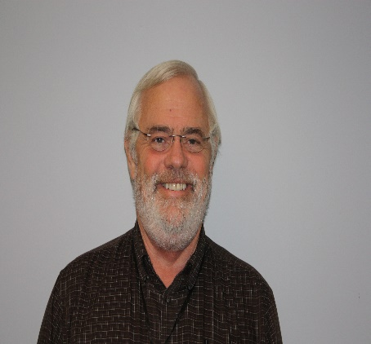

Education and Experiences

1970 -2010 WV Army National Guard
Trained as a medic and an environmental health specialist
Retired as the State Food Service Sergeant
1975 – BS Marshall University, Zoology
1977 – MS Marshall University, Biological Sciences
1978 – 1979 Adjunct Faculty, SWVCC, Williamson
1978 – 1979 – Mason County Health Department
Sanitarian
1979 – 2015 – Cabell-Huntington Health Department
Sanitarian, Sanitarian II, Registered Sanitarian, Chief Sanitarian and Program Manager over Environmental Health and Threat Preparedness.
2008 – 2015 – Marshall University, Adjunct Faculty
Taught classes in Biology for the college of Science and Environmental Health in the School of Public Health
2015 – Present – Kanawha-Charleston/Putnam County Health Departments
Director of Environmental Health Services

I have been the President of the WVALHDs in 2011 and successfully negotiated the funding between the State and LHDs for Threat Preparedness. I served on the TP Oversite Committee from 2011 – 2015.

I have been the President for the WVAS twice and served as a Member-At-Large for the WVPHA.

What do you feel is the biggest challenge the WVAS has to face over the next few years?
While it is not the only challenge for LHDs, consistent and permanent operational funding will always be a top priority, re-establishing an efficient working relationship with the Bureau of Public Health and raising the salaries of sanitarians.

What do you think you can do to help the association face this challenge by serving as President?
My career has always been about negotiation and developing working relationships. This was a lesson that I learned from John Cooper, who was a former administrator for the Jefferson County Health Department. We will always be in a political environment where we will have to give and take to achieve what we need to function in the most efficient and effective manner. We as local health departments must work together to be strong enough to survive and put aside some of our prejudices towards each other and the Bureau. Each LHD is its own entity and any plan that is developed must recognize this fact and be flexible enough to allow growth for each LHD. This can only be accomplished through strong communications and inclusion.

WVAS Candidate for 2 Year Board Member

Gillian Beach, RS, CPO-I
Environmental Health Manager, JCHD

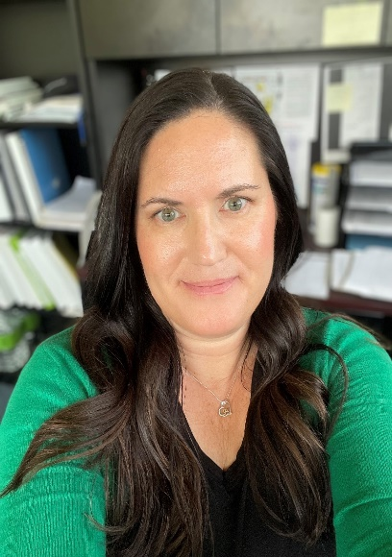

In 2018, Gillian began working at the Jefferson County Health Department (JCHD) after they lost all of their sanitarians. Gillian started out as a Sanitarian and in 2019 she took her NEHA REHS Exam and became a Registered Sanitarian in WV. In November of 2019, Gillian was promoted to Sanitarian Supervisor. Gillian has been helping Jefferson County work on the Voluntary National Retail Food Regulatory Program Standards and in 2021 she secured $250,000 in grant funds for the EH Program. From July 2020 to October 2021, Gillian was also the Acting Administrator for JCHD and helped to manage the COVID response in Jefferson County. She was also able to secure higher starting salaries for most of the positions at JCHD while serving in this role. Gillian recently completed a year long Environmental Leadership Academy program offered by NEHA.

Prior to working in Jefferson County, Gillian was an environmental health specialist in Loudoun County, Virginia. In that time, Gillian conducted food establishment inspections, hotel inspections, childcare inspections, swimming pool inspections and plan reviews for all of those establishments.

Gillian has been a member of the West Virginia Association of Sanitarians since 2019. She is also a member of the West Virginia Public Health Association. Gillian is a graduate of Old Dominion University with a B.S. in Environmental Health.

WVAS Candidate for 2 Year Board Member

David Whittaker
Lewis County Health Department

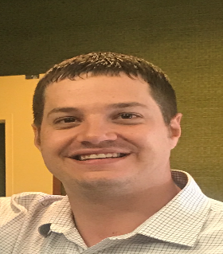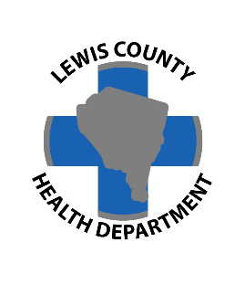

Hello, My name is David Whittaker and I am the sanitarian and administrator at the Lewis County Health Department in Weston, WV. I began at the Lewis County Health Department in August of 2008 as a sanitarian and have worked in environmental health the past fourteen years. I also became the administrator in July of 2018 and continue to hold both positions at the health department.

I have been an active member of the West Virginia Public Health Association and the West Virginia Association of Sanitarians during my time at the health department. I have served on the executive council in the past including being the President in 2017-2018 and thoroughly enjoyed my time on the board. I am again asking you to put your trust in me again to serve as an at large member, I would be humbly honored to serve again.

I grew up in the southern part of the state (Princeton) and attended both West Virginia University and Concord University, graduating from Concord in 2008. I have lived in Morgantown most recently for the past fourteen years with my wife Sarah and our son Benjamin. In our free time we enjoy the outdoors including hikes, playing golf, and attending WVU sporting events.

