4th Annual Lewistown Truck & Tractor Pull

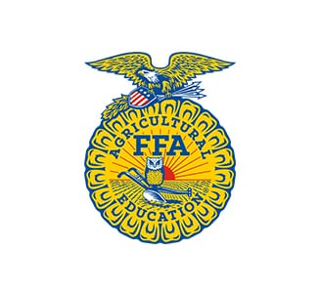 | 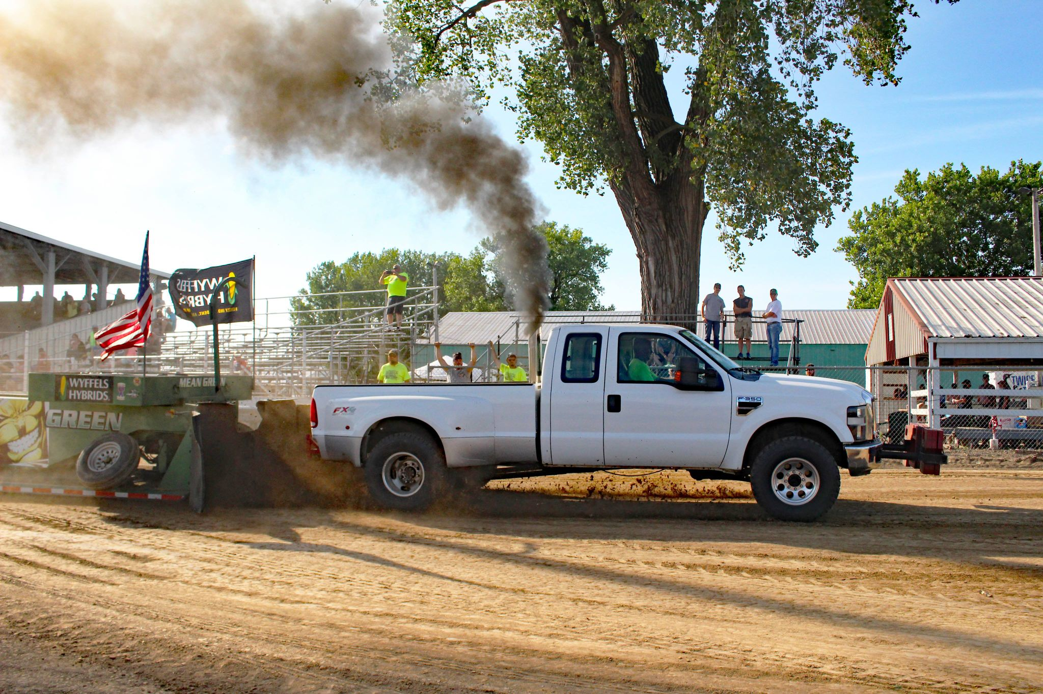 | 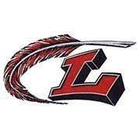
Pit Pass  $15 | Kids 10 & Under  Or  Students with ID  FREE | Grandstands $10

Truck Classes  Stock Gas Trucks  Hot Street Gas  Pro-Stock Gas/Super Stock  Modified Gas  Daily Driver Diesel  Stock Turbo Diesel  Work Stock  Open Gas Diesel | Pulling Associations  United Pullers of America  Central Illinois Truck Pullers  Illinois Farm Pullers Association  Back Roads Pulling Team  Rules and more information can be found online at:  http://www.LewistownTruckandTractorPull.net | Tractor Classes  11000 Farm Stock  12000 Farm Stock  12500 UPA Farm Stock  10000 Pro Farm  5700 Classic Mods

Come out to the Fulton County Fairgrounds and watch the truck and tractor pull! With 13 classes, you’ll see a great show with lots of dirt throwin’ and diesel smokin’ action! Benefit the local FFA students by joining us for the show, Food stand and other vendors serving all day. Tshirts available for purchase, 50/50 raffle and giveaways!
-Pits Open at 10:00 AM  -Gates open at 11:00 AM  -Pulling begins at 12:00 PM | Visit us on Facebook:  LewistownFFAPull | V
Donations & Sponsorships can be sent to: P. O. Box 11, Bryant, IL 61519

