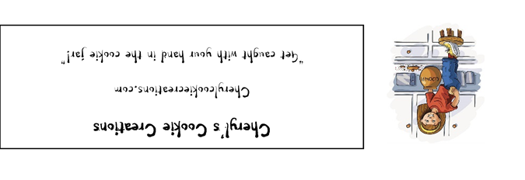

P-NUT BUTTA LUVA
Ingredients Bleached, enriched flour (wheat flour, niacin, reduced iron , thiamine mononitrate, riboflavin, folic acid), Salt, Monosodium Glutamate, Peanut Butter (Roasted peanuts, sugar, contains 2% or less of: molasses, fully hydrogenated vegetable oils (rapeseed, cottonseed, soybean), salt), All-vegetable shortening (Soybean oil, fully hydrogenated palm oil, palm oil, mono and diglycerides, TBHQ and citric acid), Sugar, Brown Sugar (sugar, molasses), Eggs, Vanilla extract, Leavening (Sodium Bicarbonate, Sodium Aluminum Sulfate, Monocalcium Phosphate), Leavening (Corn Starch, Sodium Bicarbonate, Sodium Aluminum Sulfate, Monocalcium Phosphate), Salt, Calcium silicate (an-anti-caking agent), Dextrose, potassium iodide, Peanut butter candy pieces (sugar, partially defatted peanuts, hydrogenated vegetable oil, artificial color, corn starch , salt, resinous glaze lecithin, modified corn starch, carnauba wax, vanillin (artificial flavor, milk), Peanut Butter Cups (milk chocolate [sugar; cocoa butter; chocolate; skim milk; milk fat; lactose; lecithin (soy); PGPR]; peanuts; sugar; dextrose; salt; TBHQ and citric acid, to maintain freshness)
CONTAINS WHEAT, PEANUTS, MILK AND SOY INGREDIENTS
Cheryl's Cookie Creations
Liberty Township, Ohio 45044

NET WT 5 oz (142 g) This product is home produced.

Cookies may contain: Dairy, Eggs, Tree Nuts, Peanuts, Wheat, Soy

