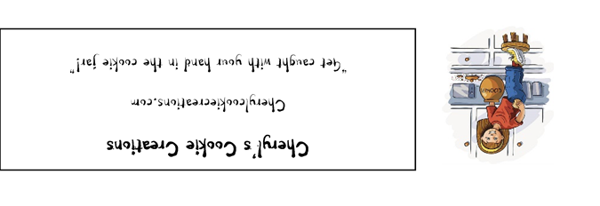

SORRY, NOT SORRY
Ingredients Bleached, enriched flour (wheat flour, niacin, reduced iron , thiamine mononitrate, riboflavin, folic acid), Salt, Monosodium Glutamate, Peanut Butter (Roasted peanuts, sugar, contains 2% or less of: molasses, fully hydrogenated vegetable oils (rapeseed, cottonseed, soybean), salt), All-vegetable shortening (Soybean oil, fully hydrogenated palm oil, palm oil, mono and diglycerides, TBHQ and citric acid), Sugar, Brown Sugar (sugar, molasses), Eggs, Vanilla extract, Leavening (Sodium Bicarbonate, Sodium Aluminum Sulfate, Monocalcium Phosphate), Leavening (Corn Starch, Sodium Bicarbonate, Sodium Aluminum Sulfate, Monocalcium Phosphate), Salt, Calcium silicate (an-anti-caking agent), Dextrose, potassium iodide, High fat cocoa, Cocoa processed with alkali, Peanut Butter Cups (milk chocolate [sugar; cocoa butter; chocolate; skim milk; milk fat; lactose; lecithin (soy); PGPR]; peanuts; sugar; dextrose; salt; TBHQ and citric acid, to maintain freshness), , Buckeye (Confectioner’s sugar [sugar, corn starch], peanut butter [roasted peanuts, sugar, partially hydrogenated cottonseed and canola oils, salt], Chocolate coating [sugar, partially hydrogenated palm kernel and cottonseed oils, nonfat dry milk, cocoa processed with alkali, cocoa, glycerol lacto esters of fatty acids, soy lecithin, mono & diglycerides, sodium benzoate-preservative, citric acid, artificial flavor, beta-carotene color, vitamin a palmitate added, dairy whey]), Peanut butter chips ( partially defatted peanuts, sugar, hydrogenated vegetable oil [palm kernel oil, soybean oil], corn syrup solids, dextrose, reduced protein whey, contains 2% or less of: salt, palm kernel oil, vanillin, artificial flavor, lecithin)
CONTAINS WHEAT, PEANUTS, MILK AND SOY INGREDIENTS
Cheryl's Cookie Creations
Liberty Township, Ohio 45044

NET WT 5 oz (142 g) This product is home produced.

Cookies may contain: Dairy, Eggs, Tree Nuts, Peanuts, Wheat, Soy

