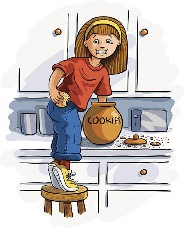
Cheryl’s Cookie Creations
Cherylcookiecreations.com
“Get caught with your hand in the cookie jar!”

VEGAN CHOCOLATE CHIP

Ingredients: Bleached Enriched flour ( wheat flour, niacin, reduced iron, thiamine mononitrate, riboflavin, folic acid, Coconut Oil, Brown Sugar (sugar, molasses), Vanilla extract, Food Starch-Modified, Salt, Monosodium Glutamate, Leavening (Sodium Bicarbonate, Sodium Aluminum Sulfate, Monocalcium Phosphate), Coconut milk (water, coconut), Applesauce (apples, water, ascorbic acid), Dark chocolate morsels (Organic chocolate, organic cane sugar, organic cocoa butter.

CONTAINS WHEAT INGREDIENTS

Cheryl's Cookie Creations
Liberty Township, Ohio 45044

NET WT 5oz (142 g) This product is home produced.

Cookies may contain: Dairy, Eggs, Tree Nuts, Peanuts, Wheat, Soy

