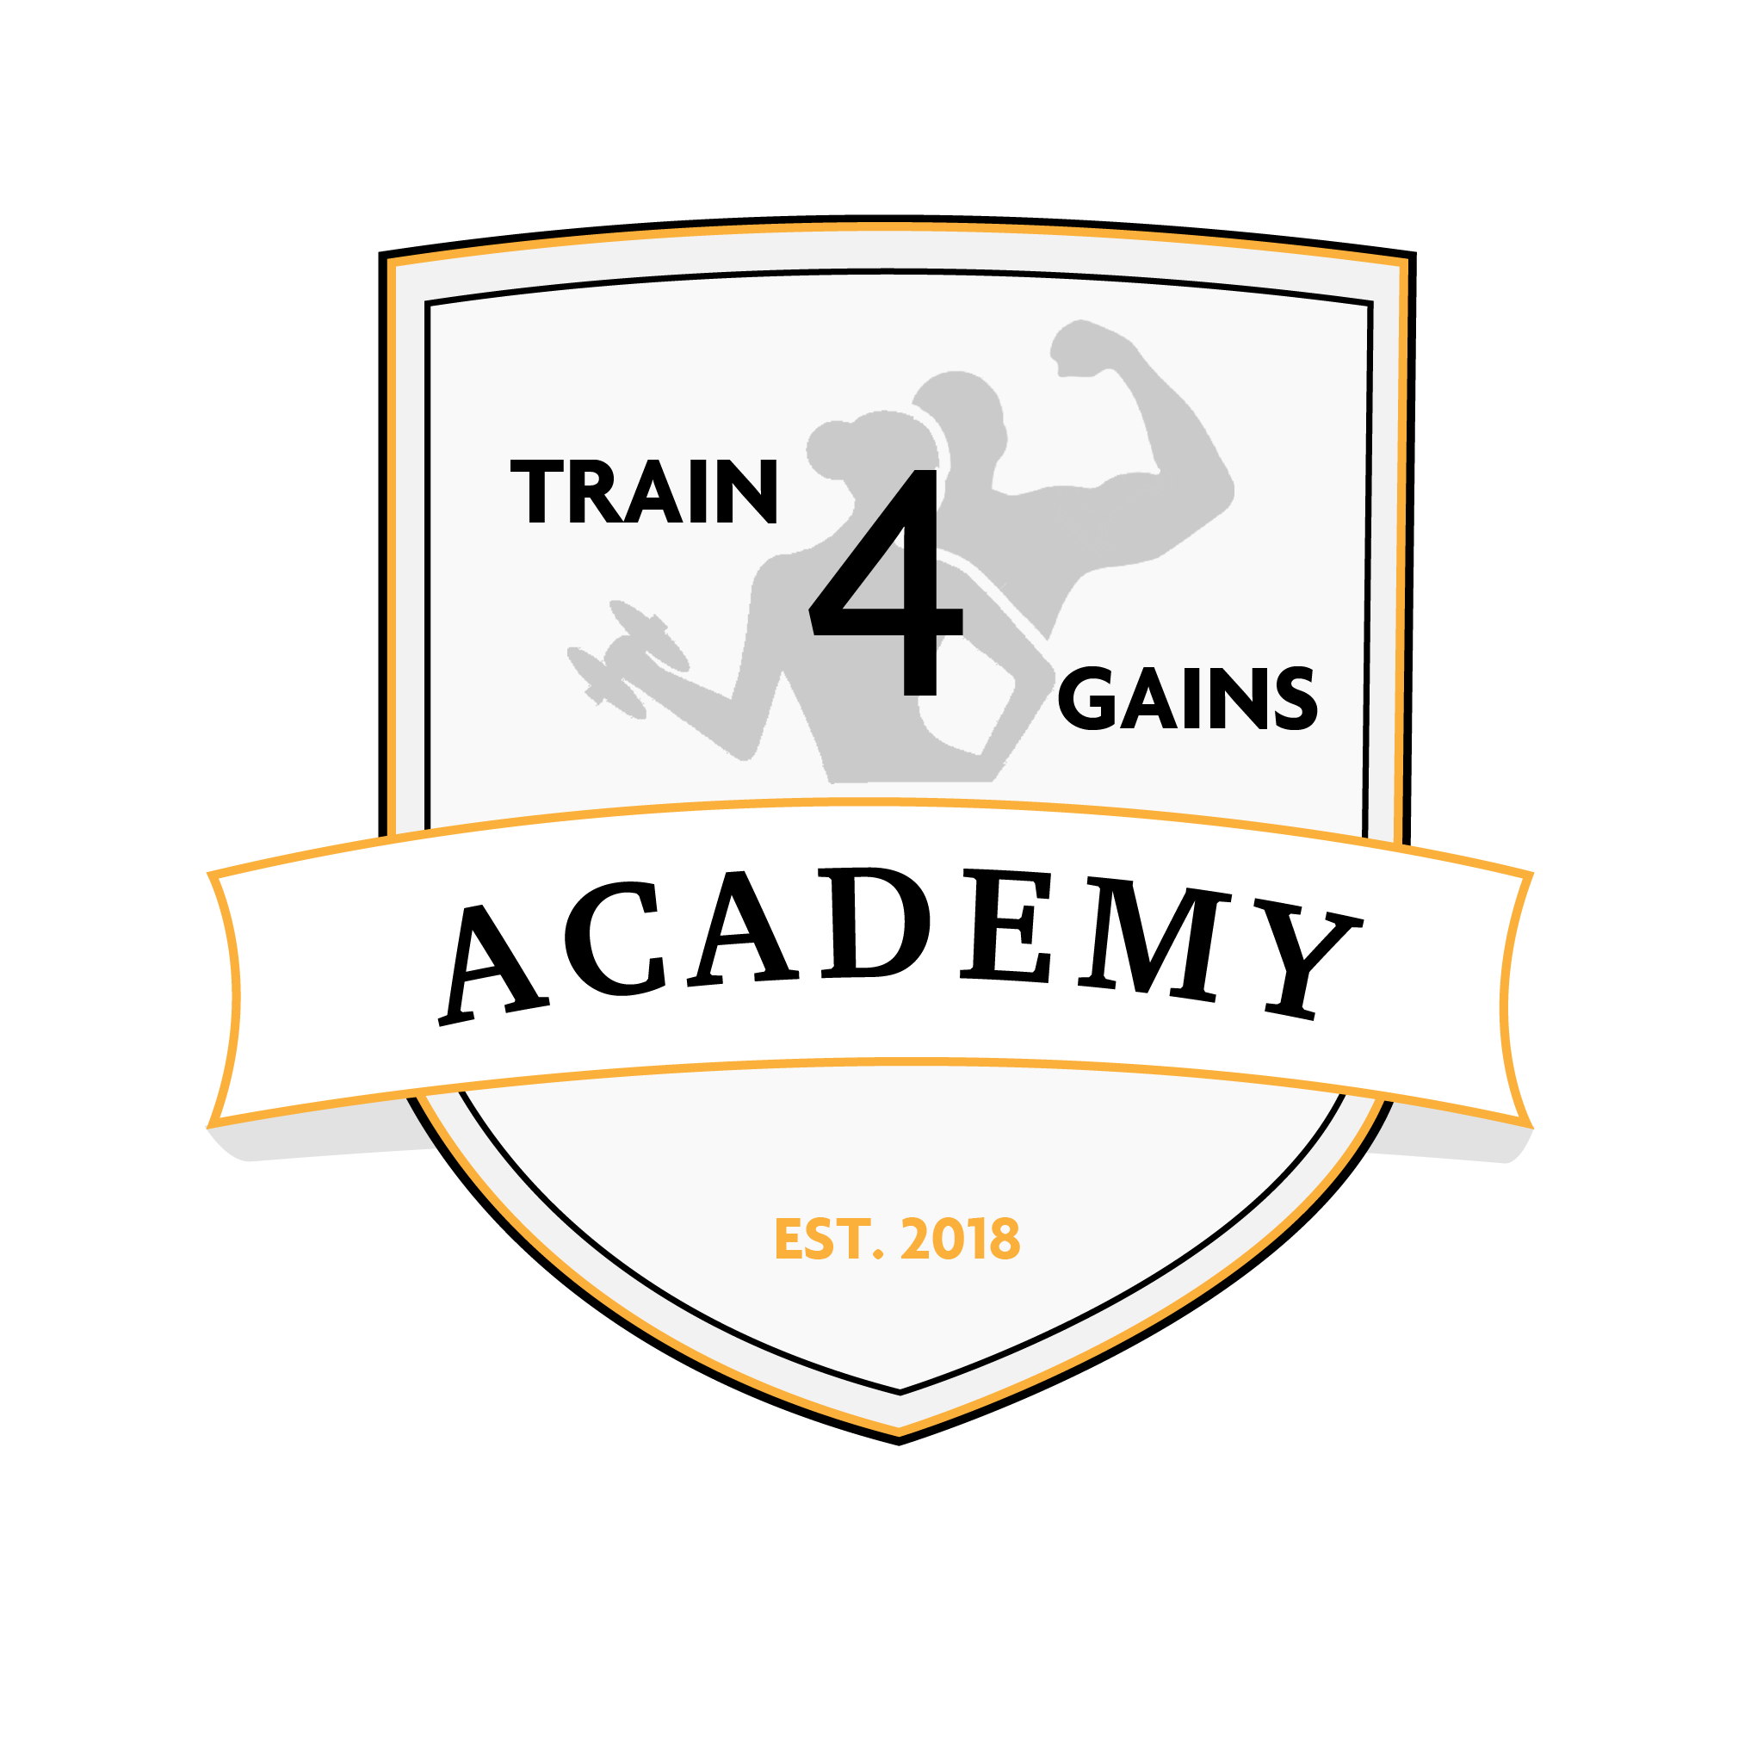**Disability Policy**

The Disability Policy reinforces Train for Gains Academy commitment to ensuring equality of opportunity for our students. We aim to ensure that students with any form of disability have access to a learning environment that meets their needs, rights, and requirements. We take pride in creating a working, learning and social environment that is inclusive of everyone.

**Definition of Disability**

The Equality Act 2010 uses a wide definition of disability which includes those with physical or mobility impairments, visual impairments, hearing impairments, dyslexia, dyspraxia, dyscalculia, ADHD, medical conditions, mental health difficulties, autistic spectrum conditions, Chronic Fatigue Syndrome, M.E. and ‘unseen disabilities’ (e.g. asthma, epilepsy, heart conditions, diabetes).

The definition of “day to day activities” includes mobility, manual dexterity, lifting, hearing, eyesight, speech, memory, and the ability to concentrate, learn or understand. The Act defines “substantial” as being more than trivial and “long-term” as being more than twelve months or likely to last twelve months. An impairment which would substantially affect a person, but which is controlled by medical treatment or prosthesis, is still covered by the definition of disability.

**Objectives**

Train for Gains Academy is committed to ensure that there are no barriers for students with disabilities. Our Objectives are:

* To ensure current and prospective students with disabilities are not discriminated against
* To ensure that wherever possible, reasonably adjustments are put in place for students with disabilities
* To provide equality of opportunity in retention, progression, and career development
* To provide and promote a positive learning environment
* To encourage disability disclosure among students, whether this be short or long term impact. Ensuring that this information is kept confidential
* To work with students to determine their support needs while on a course

**Responsibility**

Train for Gains Academy is responsible for the well being of any students with a disability. Management and the Safeguarding Officers are responsibly for ensuring that the policy is understood and well communicated. As such, all staff are responsible for ensuring that they adhere to the relevant sections of this policy.

If you have concerns about disclosure and would like to discuss these confidentially please contact one of our Safeguarding Officers:

|  |  |  |  |
| --- | --- | --- | --- |
| **Designated Safeguarding Officers** | | | |
| Name | Role | Email | Phone number |
| William Kamara | Director | Williamkamara87@hotmail.com | 07722918946 |
| Ben Warden | Tutor | Bjs44@hotmail.co.uk | 07830116768 |

**Disclosure**

Although we encourage disclosures of any disabilities, it is a personal matter of which the individual can choose if and when to do so. Train for Gains Academy will explore opportunities to implement appropriate support.

For any current or prospective students with disabilities, this could mean:

* Alternative practical assessment arrangements
* Access to learning materials in advance of course start date
* Options for additional support from tutors
* Adaptations to learning materials, where appropriate
* Options for longer time periods to complete their course

Disclosing a disability will enable Be A Better You to inform our tutors if any extra support may be needed for these individuals. These disclosures will be kept confidential, only informing other members of staff if appropriate in aiding the support of a student with any disabilities.

If any students choose not to disclose their disability, this may have implications for the support available to them. Whilst it is beneficial to disclose as early as possible, disclosing can be done at any time and can choose to what extent they want details of their disability to be disclosed or kept confidential.

**Opportunities**

Train for Gains Academy will ensure that students with disabilities have access to the full range of support services, appropriate to their needs. We will provide information about the course and venue to ensure students with disabilities can make informed choices and understand what facilities are available to them, prior to starting the course.

Tutors and Management at Train for Gains Academy plan and employ teaching and learning strategies, which make the delivery of the programme as inclusive as possible and, where reasonable, allow adaptation to accommodate disabled students’ individual requirements will also ensure that students with disabilities have the same access to the Career Development procedures we have in place for newly qualified personal trainers.

We will endeavour to provide extra support for these students, if required, to help prepare them for their interviews.

**Confidentiality**

All information given to Train for Gains Academy by disabled students will be treated with respect and confidence and in accordance with Data Protection legislation. A disabled student may disclose a disability and ask that the information is kept confidential.

**Training**

Staff will be provided with an appropriate level of training to ensure they are equipped to assist and support disabled students or prospective students.

Staff Members with SEN training:

Joy Kamara – Primary School Teacher