Hometown Realty & Property Management uses the program
Buildium in managing your rental property.

You should too…
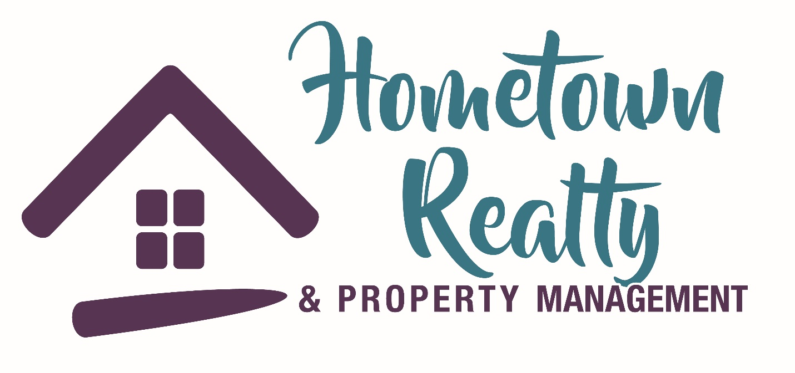
Upon completion of your rental agreement and lease, you will receive an
email with an invitation to setup your safe and secure account.

Setting up your account will:
- Allow online rent payments, even automatic drafts
- Report service/repair calls
- Grant access to rental agreements
- Update personal information
- Keep you more informed of any changes or charges
- Give you mobile access to your account
- And much more…

Write your login and password here for future reference. Once set up download :
“THE RESIDENT CENTER” App for easy login access in the future!
Your Buildium login: ____________________________________
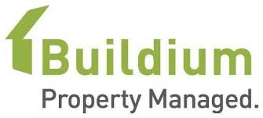
Your Buildium password: _________________________________

