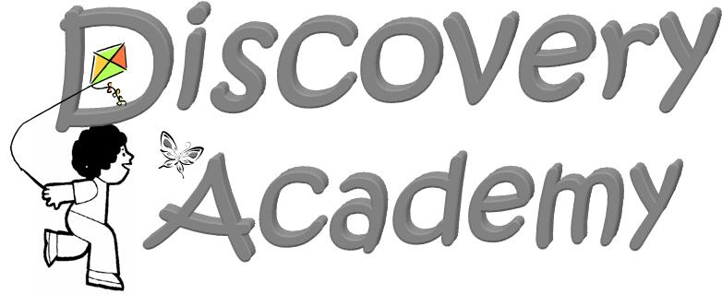
School Holidays Calendar
2025-2026

August 4, 2025 Teachers Report for Pre-Planning

August 13 &14, 2025 DAP Open Houses

August 18, 2025 Discovery Academy Classes Begin

September 1, 2025 Labor Day Holiday-No School

October 6-10, 2025 Fall Break-No School

November 4, 2025 Election Day- Teacher Work Day-
No School for Students.

November 24-28, 2025 Thanksgiving Holiday Break-No School

Dec. 22,2025-Jan. 2, 2026 Christmas Holiday Break-No School

January 5 & 6, 2026 Teacher Work Days-No School for Students.

January 19, 2026 MLK Jr. Holiday-No School

Feb. 16-20, 2026 Winter Break-No School

April 3, 2026 Good Friday- No School

April 6-10, 2026 Spring Break Week-No School

May 15, 2026 Last Day of Preschool-
9:00 a.m. – Discovery Academy PreK Graduation
(early dismissal immediately following the program).

May 18-29, 2026 Teachers Post-Planning

*This Calendar is based on the Bartow County School Calendar for extended holiday breaks.

**DAP will follow All Bartow County dismissals for inclement weather as announced.

