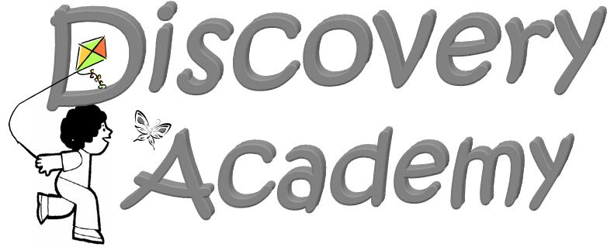
School Holidays Calendar
2024-2025

August 5, 2024 Teachers Report for Pre-Planning

August 14 &15, 2024 DAP Open Houses

August 19, 2024 Discovery Academy Classes Begin

September 2, 2024 Labor Day Holiday-No School

Sept. 30-Oct.4, 2024 Fall Break-No School

November 5, 2024 Election Day- Teacher Work Day-
No School for Students.

November 25-29, 2024 Thanksgiving Holiday Break-No School

Dec. 23,2024-Jan. 3 2025 Christmas Holiday Break-No School

January 6, 2025 Teacher Work Day-No School for Students.

January 20, 2025 MLK Jr. Holiday-No School

Feb. 17-21, 2025 Winter Break-No School

April 7-11, 2025 Spring Break Week-No School

April 18, 2025 Good Friday- No School

May 16, 2025 Last Day of Preschool-
9:00 a.m. – Discovery Academy PreK Graduation
(early dismissal immediately following the program).

May 19-30, 2025 Teachers Post-Planning

*This Calendar is based on the Bartow County School Calendar for extended holiday breaks.

**DAP will follow All Bartow County dismissals for inclement weather as announced.

