The Final Details are now set, for the Great Art of Golf Travel, Ireland Excursion, May 2-9, with the final total price is $4,395, almost $1,000 less than our trip to Scotland. It includes 7 rounds of golf, 7 nights lodging (Doonbeg, Newcastle, Portrush, Dublin), Mercedes VIP Van Transport, some meals, prizes and surprises.

https://www.youtube.com/watch?v=T93T_wxQd88#pagePolicyAuthForContinue

https://www.youtube.com/watch?v=2SetkN4sRrc
Package includes all golf, all lodging, all transportation, some meals and guaranteed good time with plenty of Craic as they say in Ireland, Call or text 972-989-2310 or e-mail astrick@flash.net for complete details. Just a $700 deposit holds your spot for this memorable Irish Golf Adventure. Already signed up some, but have a few Limited spots left, sign up now!
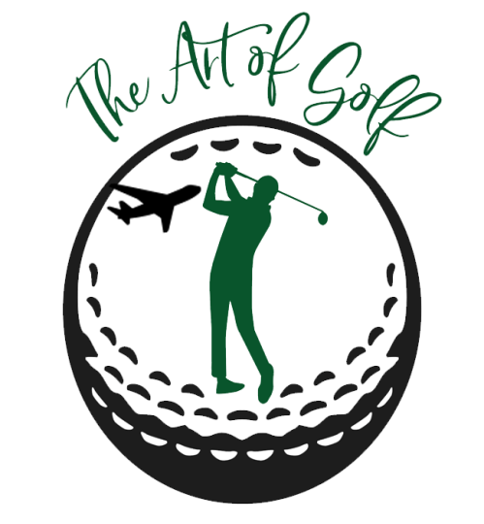

2020 Art of Golf Northern & Republic of Ireland Golf, May 2-9
Saturday, May 2, 2020 Arrive /Shannon Airport, Bus Transport,
Warmup Golf Doonbeg Links— 2:12 p.m
Overnight Doonbeg Golf Resort, No. 1 Golf Resort in Europe,
Sunday, May 3, Play Doonbeg, 10:12 a.m. Classic Irish Mounds & Links
,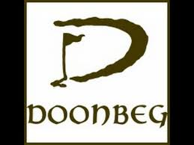
Travel to Royal County Down, New Castle overnight, historic Slieve Donard Hotel
Monday, May 4, play Royal Country Down Golf Club, 11:49 a.m.
World No. 1 Ranked Course, Purest Links Course Magic 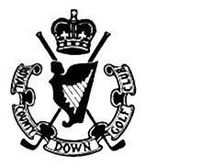
Travel To Blackrock Luxury B&B, overnight, Portrush
Tuesday, May 5 Play Royal Portrush, 2019 Open Championship Site, 3:36 p.m.
4 in UK, 15th in the World, 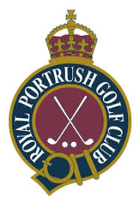
Wednesday May 6 , play Porttewart, 2017 Irish Open site 1:20/1:40 p.m., overnight Blackrock Luxury B&B,
Thursday May 7, Play CastleRock, 12:30 p.m., Hidden Irish Gem, Overnight Blackrock , Luxury B&B
Friday, May 8, Travel to Dublin, play Royal Dublin,10 a.m.
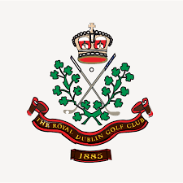overnight Dublin city Center,
Saturday, May 9, Return to USA, Dublin Airport

