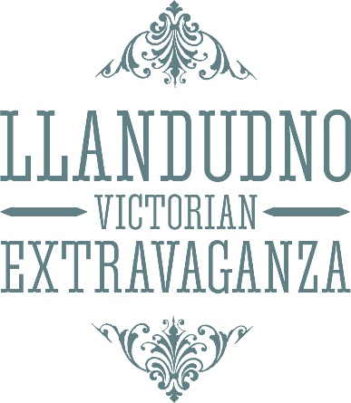

Llandudno Victorian Extravaganza
Window Display Competition
4th, 5th & 6th May 2019
Philippa Farrell (Secretary/Treasurer)
llandudnoextravaganza@gmail.com

Over the Extravaganza weekend local businesses are invited to join in the spirit of the occasion by dressing their windows in a Victorian theme. This always proves to be very popular and the organising committee would like to extend a very big thank you to all the shops, restaurants, hotels, B&B’s and businesses who take the time to participate, and at the same time have fun.
Every year the originality and standard of the displays amaze residents and visitors alike.
Certificates will be awarded to the first and second place winners in each category. We all look forward with anticipation to see this year’s displays.
There will be a prize for the overall winner - an advert for your business in our annual programme.
Judging takes place on the afternoon of Thursday the 2nd of May 2019.
If you would like to be included in the judging, please send back this form using the above details.

We (name of business) ………………………………………………………………………………………………………………………………….…
wish to enter the 2019 Victorian Window Display Competition in the following category/categories:

Large Window Display [ ]

Small Window Display [ ]

Charity Shop Window [ ]

Best Dressed Victorian Staff [ ] Judging to take place on Sunday the 5th of May 2019

