CloverConnect Integration FAQ

Can the CloverConnect integration work in non-point of sale transactions?
The current integration supports point of sale transactions for parts and service transactions only and does not support non-point of sale transactions. Anything outside of parts and service will need to be handled as an offline process. This isn’t available in any Karmak credit card integration.

How many terminals will I need to support the Karmak credit card integration?
It is recommended that each computer that processes parts and service orders have its own terminal. A Fusion customer can run multiple computers to a single terminal however it can cause issues when multiple computers are calling the terminal at the same time and can cause customer wait times or time outs.
Some customers employees have tried to cancel the transaction due to the long wait time, run the transaction again and have duplicated the charge.

Who do I call if I’m experiencing an issue?
As a rule of thumb, if the issue resides in Fusion as part of processing a transaction the call needs to go to Karmak support. Here are some examples of Karmak support issues:
- Error message when processing a transaction
- Difficulty in crediting a part or core
- Handling tokenized credit cards
If you are calling Karmak support for assistance, please take screenshots and provide as much detail about the transaction as possible to help Karmak’s support team in understanding how you were using Fusion when the error occurred. If deemed to be a processor issue it will be required to call the processor directly.
If the issue is happening after the transaction, the call needs to go to CloverConnect. Here are some examples of processor support issues:
- A transaction didn’t go through
- Accessing information through the processor backend system or login issues
- Long wait times for processor customer support
- Billing issues

Will Fusion now be able to handle partial payment or multiple payments with this integration?
Karmak Fusion does not support multiple payments options with this integration.
Work around:
Fusion will only process transactions for the exact invoice amount. There is no way to tell the system that part of the payment will be in another form and reduce the credit card invoice by the cash amount. To accept multiple forms of payment that include credit card, make two invoices, one credit card and one cash to properly account for the payments. To charge the correct amount, we need to reduce the credit card payment method invoice and create a second invoice for the cash amount tendered.
- Confirm the amount of payment to be paid with credit card
- Subtract that amount from the invoice total
- Add the misc. billing option line “Worldpay Cash/Check Payment” with the cash payment amount in the form of a deduction
- Invoice the transaction through WorldPay payment method
- Immediately create a new invoice
- Add the misc. billing option line “Cash/Check payment offset” with the cash payment amount in the form of a charge
- Set the proper payment method
- Invoice and collect payment
Example: Invoice is $300. Customer wants to pay with $100 cash and $200 credit. Invoice #1 (original purchase invoice): Reduce, using misc. code, by $100, making the total charged invoice $200. Invoice #2: $100 for a combined total of $300.
Does CloverConnect support Level 2 and Level 3 processing? Yes
Who sets up the terminals in Fusion?
CardConnect has an installation team that will assist with setting up the terminals in Fusion.
If the terminal has a signature capture device, where does it go?
When a customer uses a signature capture credit card terminal the signature is then added and stored on the invoice. CloverConnect will have the functionality in July 2022.
Is credit card information stored in Fusion?
No. Karmak makes an API call to the CardConnect system that stores the necessary information to process the transaction. Karmak went through extensive PCI compliance testing to certify as a partner.

Can a customer get a demo of how it works in Fusion?
Unfortunately Karmak doesn’t do demos for the credit card integrations due to its simplicity.
How do I handle core returns in Fusion?
- Create new parts order to the customer that the part was originally sold. Select “Right to Return Core’s and select the dirty core return you wish to issue credit. 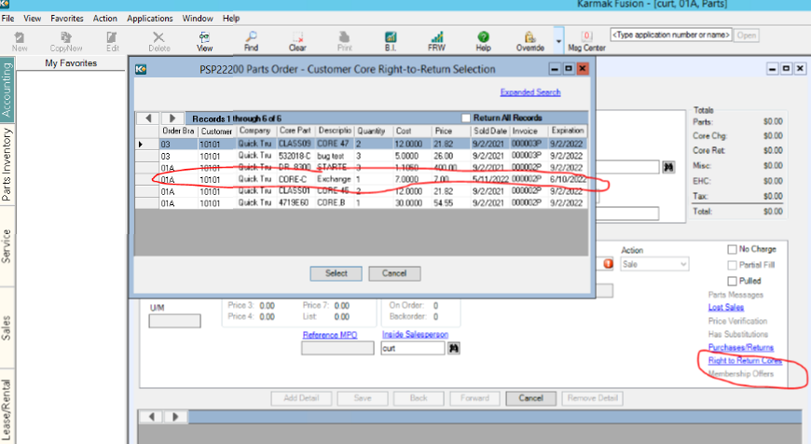
- Select “Save” to save the core return to the order. 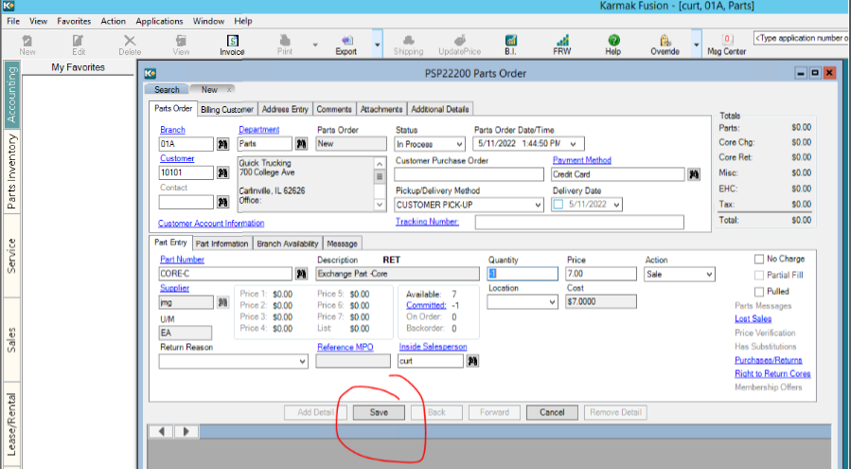
- Select “Invoice”.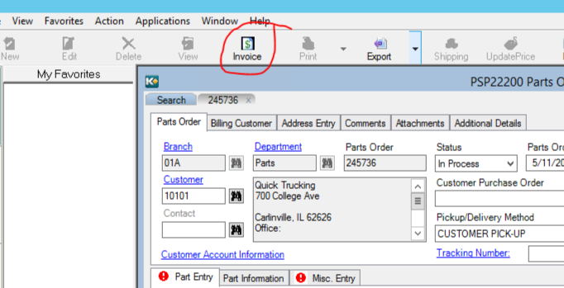
- Select “Process”.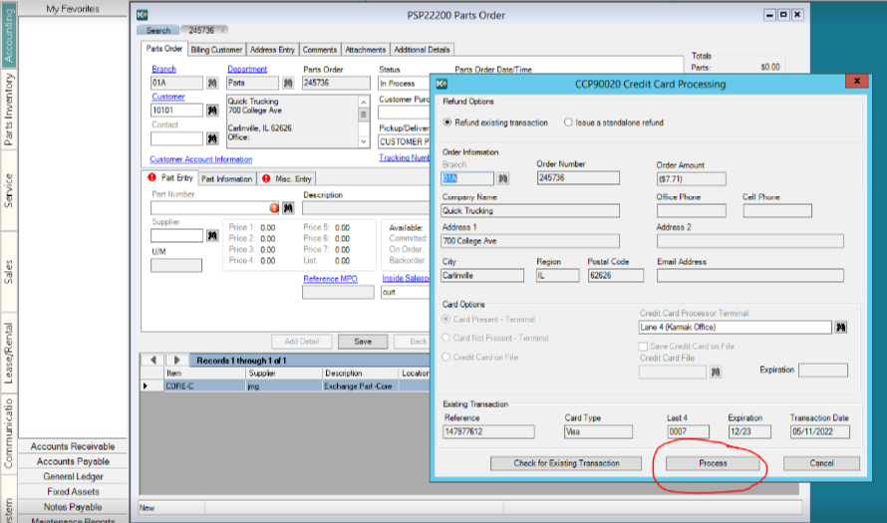
- Approved.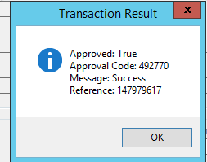

How do I handle credit card credits in Fusion?
CardConnect will only allow a credit once the terminal batch is run so it will be necessary to run the credit after the batch is completed.

