 | Go and Declare, Inc.  Main: (850) 251-7555 Website: www.goanddeclare.org

Happy New Year from the Waters Family!
Thank you to everyone who has prayed and financially partnered with us this past year. The Lord has done so many amazing things. We are now looking forward to 2026! You are a big part of this. May the Lord prosper everyone and give you good health in Jesus’ Name! We love you all.
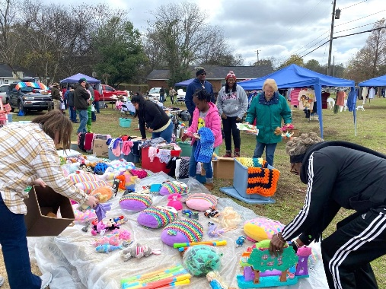
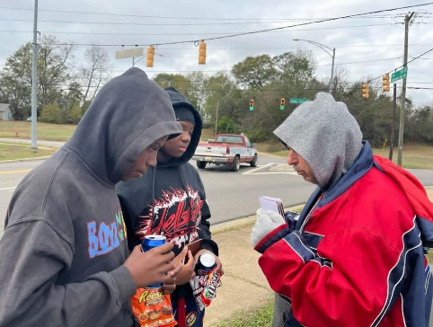
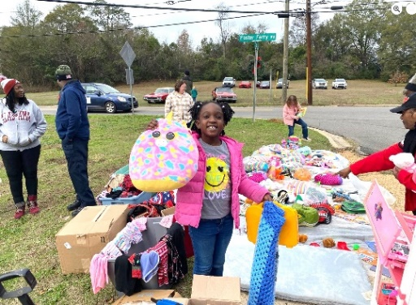
Toys for Tuscaloosa, West End Tuscaloosa, Alabama
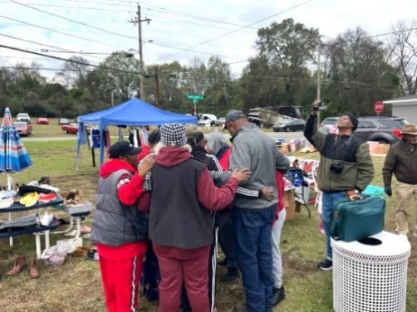
We joined with Evangelists Richard Davis, Abraham Javine, and other volunteers for the annual Christmas outreach in West End Tuscaloosa. My truck was loaded up with candy, clothes, some backpacks, bicycle helmets and toys, including plush animal pillow toys. Thank you to our friends and partners for donating items and supporting us financially to help contribute to this outreach. Many families were blessed, the gospel was shared and some folks gave their hearts to the Lord! Several young teenagers came to the outreach to receive candy and clothes, but they left with much more. Here’s a picture of the team praying for some of these boys and leading them to the Lord. All praise to King Jesus!
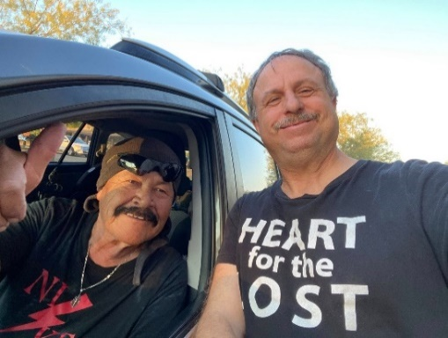
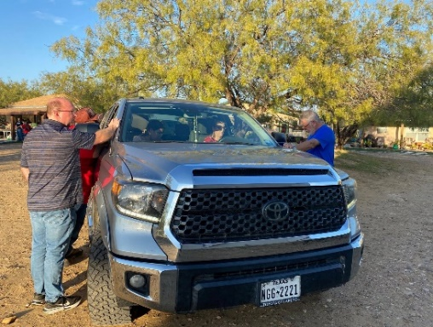
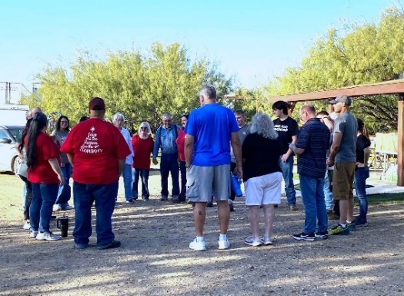
Laredo Steppingstone Drive Through Outreach, Laredo, Texas
Richard Davis and I had a great opportunity to serve on the prayer team at the Laredo Steppingstone Drive Through Outreach. Low-income families lined up in their vehicles to receive food for their families and came over for us to pray for them. We had a miraculous healing take place where this precious gentleman’s shoulders and neck were healed. Praise God! The Lord took away all his pain.

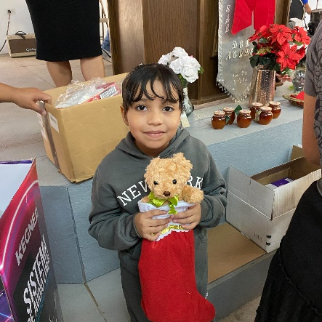
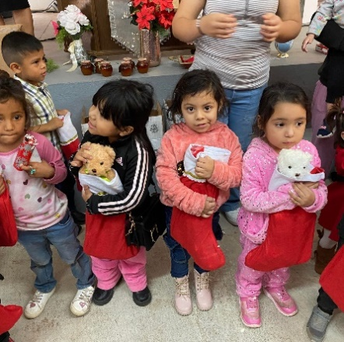
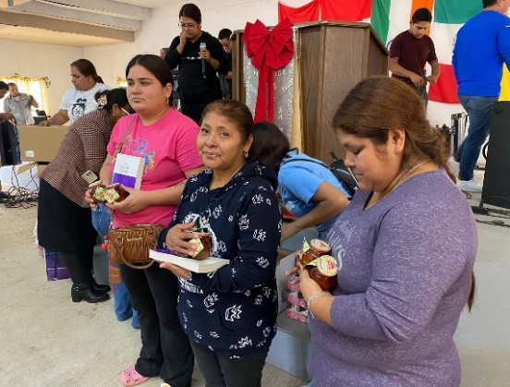
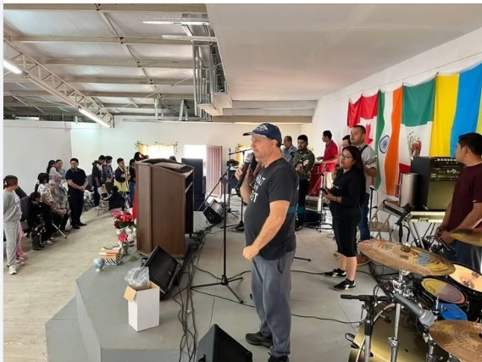
Toys for Mexico Outreach, Nuevo Laredo, Mexico
This is always one of our favorite missions every year. The Lord really moved powerfully in the outreach service. The whole atmosphere shifted as we called the people down to give their hearts to the Lord, and many came to the altar to receive Jesus. It was as though time stood still as the Lord’s presence filled the church during the worship and prayer. It was a special, holy moment in time, and then the word was preached. The people were deeply blessed. We had 200 Christmas stockings packed full of candy, Life and Teachings of Jesus books, Book and the Ball Books, and toys for the children who were so happy to receive them. Every child received a Christmas stocking, and we still had some left over plus 30 soccer balls that will be delivered to other needy children in Mexico. We also blessed families with jars of donated honey. It was a special day! All praise to King Jesus and thank you to all those who prayed and partnered with us to make this Christmas blessing possible!

Upcoming Ministry Starting January 2026!!!
With the temperatures being so cold, and concern for the homeless in our hearts, we will be doing a cold weather item drive for the whole month of January. We are collecting items such as blankets, gloves, jackets, and socks for the homeless and will be taking these items out on January 31st. Also, we are planning a trip back to Costa Rica in February or March. The Lord highlighted the Cartago and Limon provinces to us. Our assignment is to hold Holy Spirit led meetings and help the pastors to go after the lost. Please help us pray for revival and evangelism in Costa Rica! To make a donation, checks can be written to Go and Declare Inc. and mailed to 1117 Colbert Avenue, Pensacola, FL 32507. Folks can also give by clicking on the donation button on our website, www.goanddeclare.org or at any of the app links listed below. Our Square link is specifically set up for recurring monthly donations, which is our biggest need!
Go and Declare, Inc - Go and Declare Inc (square.site)
https://www.paypal.com/paypalme/goanddeclare
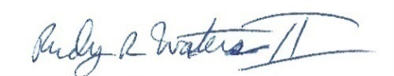
Pay $goanddeclare on Cash App
Venmo | Go and Declare Inc

Rudy R Waters II
Your Servant to the Lost, the Least, and the Last!
850-281-7555 www.goanddeclare.org

Go and Declare, Inc. is a Christian nonprofit, designated as a tax exempt organization under Internal Revenue Code Section 501(C)(3). Go and Declare's EIN number is 81-1668702. We are a Florida Corporation registered with the State of Florida Division of Corporations, document number N16000001760.

