|  |  |
| --- | --- |
|  | Go and Declare, Inc.  Main: (850) 251-7555 Website: www.goanddeclare.org |

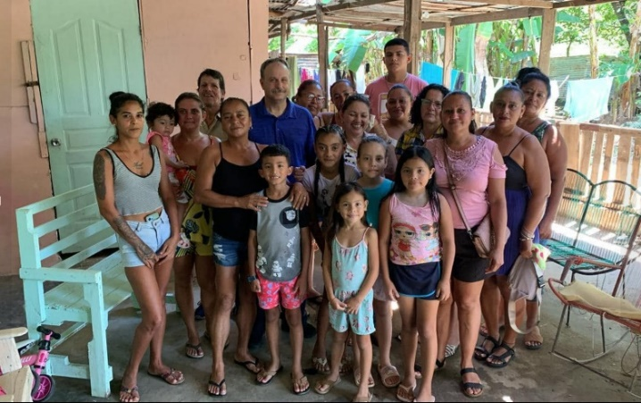**Costa Rica Missions Trip 2024**

**Puntarenas, Costa Rica**

It was a powerful time of ministry with these ladies who work at jobs cleaning the beach in Puntarenas. Brother Frank Gutierrez’s foundation provides these jobs to help the women to sustain their families. Most of these precious women came out of a life of prostitution. Several shared their testimonies of how the Lord had set them free. As they spoke, I could feel God’s compassion in my heart for them. The Lord moved powerfully with healing, salvation, releasing unforgiveness, and the Baptism of the Holy Spirit!

**Powerful Meeting at Multiplied by the Word Church in Puntarenas Saturday Evening!**

The worship in this church was incredible. The Lord had me share on how powerful our worship is to the Lord and how our worship changes the atmosphere of our cities. I shared with them how important it is to take what they are receiving from the Lord out to the lost. We met a gentleman who worked at the Ministry of Health Department and the Lord led us to pray for him. God gave me several words of knowledge for him and his wife. The Lord showed me that this couple was the reason we were there that evening. I believe the Lord is raising him up to one day run for office in Costa Rica!

**Regen Water Company**

This was a huge divine appointment! Frank took me to visit this water company. We met the owner, Pietro, and had several visits with him. He gave us a tour of the water company. He has a special formula for alkaline water. Pietro is a nonbeliever and really didn’t want to hear about the Lord. After visiting him several times his heart started opening up to us and he let me pray for him. The Lord gave me several words of knowledge for him, and he shared with Frank later that no one had ever prayed for him before. I left him with my testimony tract to read. The Lord is opening Pietro’s heart. Please pray for him!

**Delivering Supplies to Families in the Mountains**

Mission accomplished! We brought supplies to the families in the mountains! They have been on my heart since 2019! All the children were in school, but we spent time praying for Rosa, her two daughters and her son! Please pray for these families! There are a total of 18 people living here in these homes! It is very heartbreaking, but the Lord continues to provide for them!

**Spontaneous Pastors Conference in Puntarenas**

It was a powerful time with some of the foundation pastors in Puntarenas! The Lord’s presence dropped on them powerfully! They have a burden to continue to pray for God to send awakening here! They had me share testimonies of revival in Pensacola and other places. It’s my favorite topic. After sharing we began to pray! The pastors started repenting and crying out for revival and awakening! The presence of the Lord came and refreshing and healing came over them and their wives! It was a very special time!

**Two Women Healed at Word into Action Church**

**Women’s Celebration**

We were invited to come share by Pastor Jose at the Women’s Celebration at Word in Action Church in Puntarenas that evening. The Lord had me share on declaring God’s Kingdom on the earth! Frank and I had an opportunity to pray for the Lord’s Kingdom to come in the meeting. We had two ladies healed. One of the ladies had a hard time walking for 22 years and the Lord healed her. It was an awesome sight to see her walking around the building with no pain. All praise goes to King Jesus!

**On to Our Next Assignments! Toys for Tuscaloosa**

**and Nuevo Laredo, Mexico**

This is our favorite time of the year. On December 9th Brother Richard Davis and Pastor Javine will be having a Christmas Outreach in West End Tuscaloosa. We will be bringing up a truck load of toys. Then on December 11th, I fly out to Laredo, Texas for our Toys for Mexico Trip. This year we will be purchasing items in Laredo to send across to Mexico for the December 14th outreach. We still could use funds! What an opportunity to see the faithfulness of Jesus!

**Thank You**

We want to thank you all so much for partnering with us this year! Wow! The Lord has been doing so many incredible things. Thank you so much for your prayers and partnership! You are all our family, and we pray the Lord will richly bless everyone with good health and increase in all your finances. I believe the best is yet to come!

**To make a donation, checks can be written to Go and Declare Inc. and mailed to 1117 Colbert Avenue, Pensacola, FL 32507. Folks can also give by clicking on the donate button on our website, www.goanddeclare.org or at any of the app links listed below. Our Square link is specifically set up for recurring donations, which is our biggest need! Believe with us for monthly partners as we operate on a limited budget! What an opportunity to see the faithfulness of God! He is good all the time!**

[**Go and Declare, Inc - Go and Declare Inc (square.site)**](https://checkout.square.site/merchant/MLHNGHTFXQKJA/checkout/4W3NWBZTUABVGHIUNAVURSHA)

<https://www.paypal.com/paypalme/goanddeclare>

[Pay $goanddeclare on Cash App](https://cash.app/$goanddeclare)

[Venmo | Go and Declare Inc](https://account.venmo.com/u/GoandDeclare-Inc)

Rudy R Waters II

Your Servant to the Lost, the Least, and the Last!

850-281-7555 [*www.goanddeclare.org*](http://www.goanddeclare.org)

*Go and Declare, Inc. is a Florida Tax Exempt Non-Profit Corporation*.