|  |  |
| --- | --- |
|  | Go and Declare, Inc.  Main: (850) 251-7555 Website: www.goanddeclare.org |

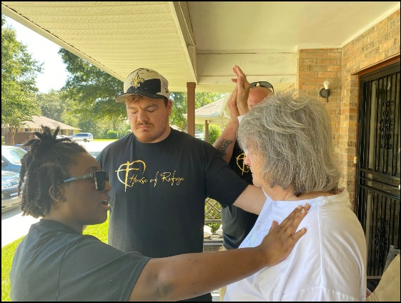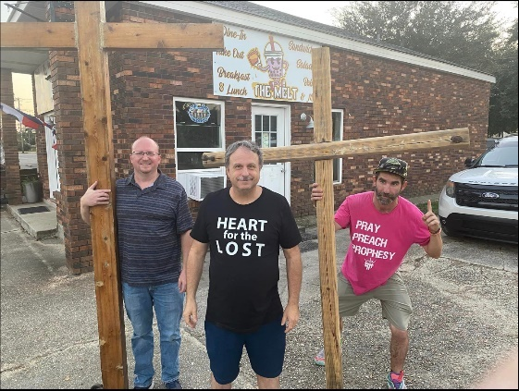

**House of Refuge Picayune, Mississippi, Evangelism Training and Outreach and Sunday Service**

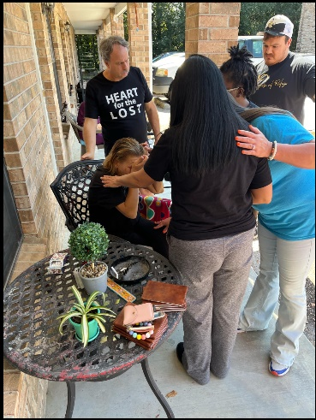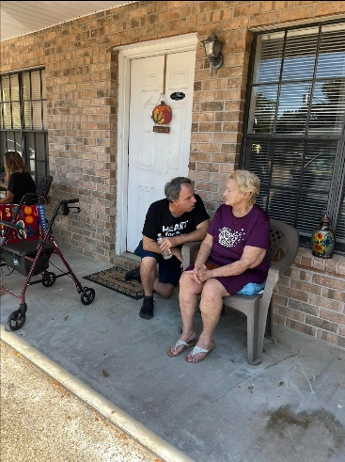Brother Richard Davis and I had an amazing time in Picayune with our House of Refuge Family. We had an evangelism training session at the church and then we went out to two different apartment complexes. We had all kinds of divine appointments that day. In the pictures above, the one on the right shows our team praying for Phyllis’s rotator cuff. Phyllis said it felt much better, and she was lifting her left arm above her head before we left! Praise God! The two pictures on the right are of our team praying for a mom and daughter. It turned out that the mom had just lost her husband, and she was grieving. She came out and sat in the chair outside, and the team prayed with her and loved her. She gave her heart to Jesus! The Lord led us to pray for the daughter to let go of unforgiveness and she did. It was a great day! Later in the evening, Richard, Billy, and I took the crosses into downtown Picayune. We held them up on one corner while street preaching. Down the street from us was a family holding up signs on the other corner! It was a special night! The next day the Sunday morning service was incredible! Brother Richard Davis and I each shared a word from the Lord and the Holy Spirit showed up powerfully! Several people came to the altar for prayer and two ladies received the baptism of the Holy Spirit and their prayer language. We love our House of Refuge Family!

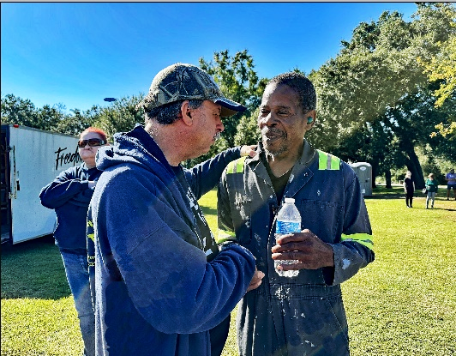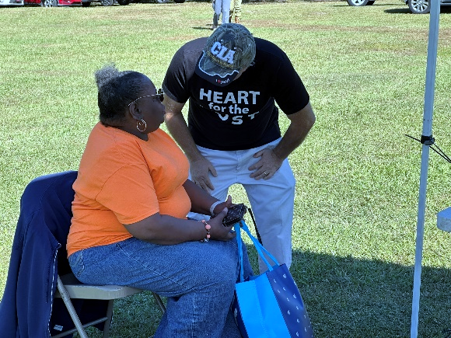

**Reimagine, Cantonment, Florida**

It is such a blessing when the Body of Christ gathers together to meet the material and spiritual needs of the community! We worked with Freedom Church volunteers to pray with folks at the Popcorn and Prayer tent and ministered to those waiting in line for groceries. My heart was deeply touched by a precious gentleman who received Christ as his Savior that day. There were two Christian ladies there who were suffering in pain but received miracles. One of these ladies had pain in both knees. She said she had been through many medical tests, but her doctors could not find the cause. As we prayed over her Jesus touched her! She got out of the chair praising God because all the pain had left both of her knees! Glory to God! Hallelujah! The other dear lady had 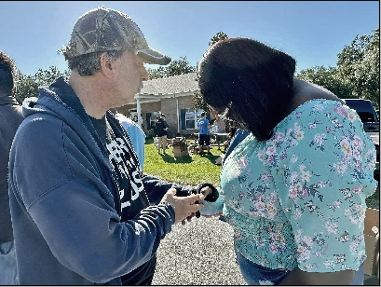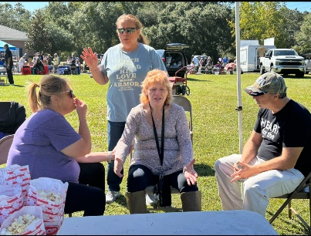nerve damage in her wrist. We prayed over her and God gave her a miraculous healing! The pain left her arm! We are overwhelmed by the goodness of God and His love for us all.

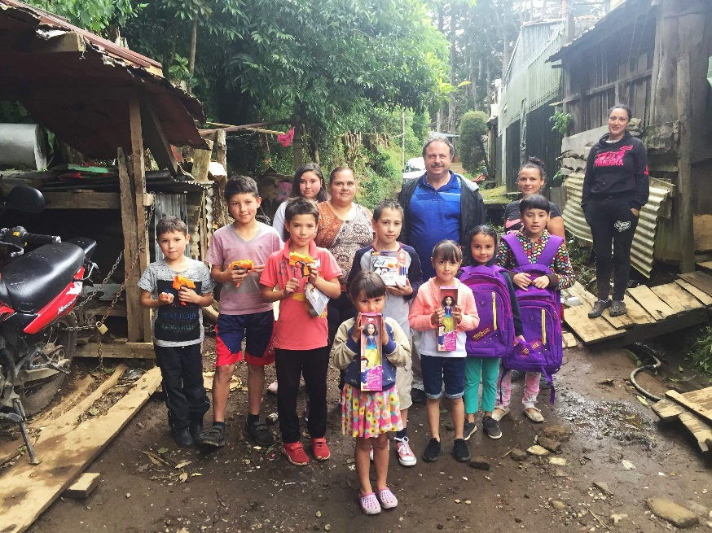

**Excited for Costa Rica! I’m Leaving October 31st!**

I’m so excited that I head to Costa Rica on October 31st! I was just talking to Frank and there is a possibility we may visit the US Embassy on election day to pray for our elections on November 5th. I believe this will be the best trip yet. We still could use some finances for the trip. We know the Lord will provide. What an opportunity to see the faithfulness of Jesus!



**Christmas Nuevo Laredo, Mexico and Laredo, Texas Missions Trips December 12th-19th 2024**

When I return from Costa Rica, we start planning for our Christmas Missions Trip to Nuevo Laredo, Mexico on December 12th. This year Richard Davis and I will fly to Laredo, Texas, and purchase toys and items needed for the outreach. In November we will start our fundraising for the toys and items needed for this mission trip.

**Thank You**

We thank every one of you so much for continuing to pray and partner with us all of these years! The Lord is doing so many special things in the US and around the world! We are truly living in special times! In these last days He has called all of us for such a time as this!! The Harvest is truly ripe! Praise to King Jesus!

**To make a donation, checks can be written to Go and Declare Inc. and mailed to 1117 Colbert Avenue, Pensacola, FL 32507. Folks can also give by clicking on the donate button on our website, www.goanddeclare.org or at any of the app links listed below. Our Square link is specifically set up for recurring donations, which is our biggest need! Believe with us for monthly partners as we operate on a limited budget! What an opportunity to see the faithfulness of God! He is good all the time!**

[**Go and Declare, Inc - Go and Declare Inc (square.site)**](https://checkout.square.site/merchant/MLHNGHTFXQKJA/checkout/4W3NWBZTUABVGHIUNAVURSHA)

<https://www.paypal.com/paypalme/goanddeclare>

[Pay $goanddeclare on Cash App](https://cash.app/$goanddeclare)

[Venmo | Go and Declare Inc](https://account.venmo.com/u/GoandDeclare-Inc)

Rudy R Waters II

Your Servant to the Lost, the Least, and the Last!

850-281-7555 [*www.goanddeclare.org*](http://www.goanddeclare.org)

*Go and Declare, Inc. is a Florida Tax Exempt Non-Profit Corporation*.