|  |  |
| --- | --- |
|  | Go and Declare, Inc.  Main: (850) 251-7555 Website: www.goanddeclare.org |

**Panera Outreaches in Pensacola, Florida**

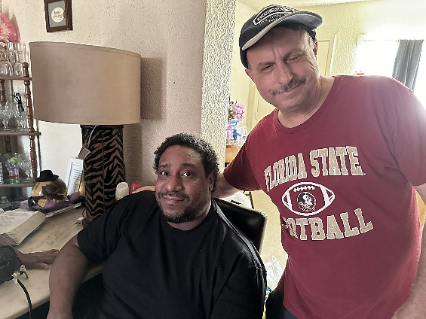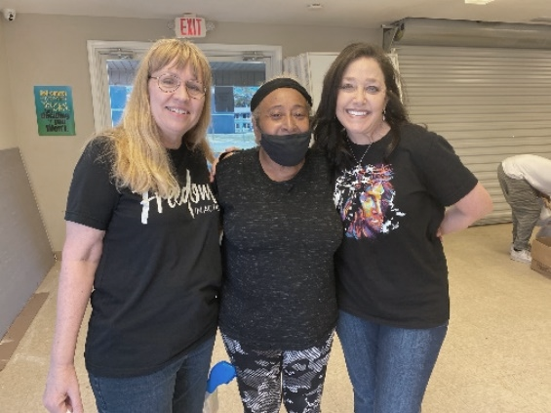Here’s an amazing testimony from the Panera Outreaches that happen every Tuesday in Pensacola. At the Oakwood Terrace Apartments I knocked on doors to tell folks about the outreach. Russell answered the door and told his mom. She came and got food and prayer! She gave her life to Jesus and received the baptism of the Holy Spirit. She brought us back to her apartment and we prayed for Russell. Russell had suffered several strokes! He gave his life to Jesus, received the baptism of the Holy Spirit, and we prayed for total healing! The Lord had us prophesy Jeremiah 29:11 over Russell. He was glowing when we left! Praise Jesus!

**Honoring Ashley Lutz**

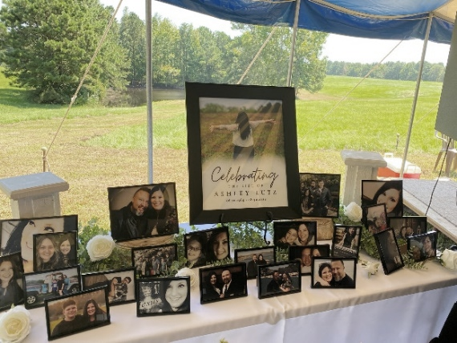After our close friend Ashley Lutz went to be with Jesus, I felt the Holy Spirit shift me away from the Convergence Conference. Instead I was led to drive out to Texas for her Memorial Service. Levi and Ashley are close family, and I knew I had to be there. The presence of God was incredible as stories were shared about Ashley and her heart for lost souls. I will never forget being on an evangelism assignment with her as she ran through Walmart to minister to a young girl and share Jesus with her. Ashley was one in a million. I believe she was the greatest one-on-one evangelist I ever knew. She is now among the cloud of witnesses cheering us on as we continue going after the lost. We love Levi, Ashley, and their precious three children and will continue to pray for their family.

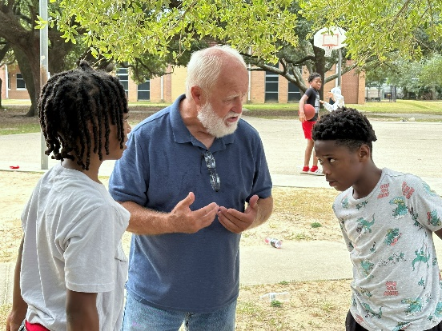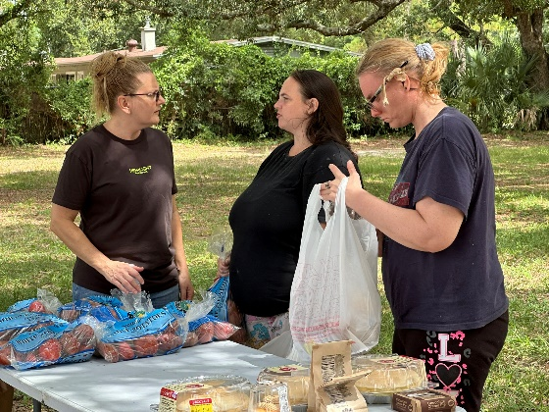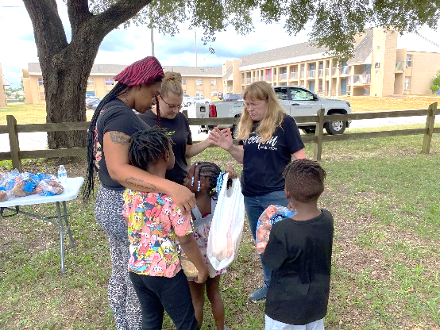**Freedom Church Storehouse Outreach at Pensacola Village Apartments, Pensacola, Florida**

The Freedom in Action Team brought boxes of cakes, cookies, breads, and pastries plus hundreds of pounds of potatoes from the Freedom Church storehouse to Pensacola Village Apartments! About 50 people were served at this outreach, many of them were children. Needy families were supplied with food and ministered to. We had all kinds of divine appointments! Several precious children gave their hearts to Jesus! It was a special day!

**Caneyville and Leitchfield, Kentucky**

Richard and I just had an incredible time out in Caneyville and Leitchfield, Kentucky with our Southside Christian Center Family! On our first evening we ministered at a tent crusade. Several churches came together for tent meetings. The presence of God was incredible! Many folks were ministered to that evening. Lives were changed. The next day, we had an evangelism event in Leitchfield. We set up outside of our friend Pam Fraim’s Stevenson’s Salvage business right next to a cigarette shop. We had several divine appointments that day. Our friend Russell Corp brought the cross there. We ministered to several folks who wanted to be free from nicotine. Richard and I ministered the rest of the weekend at Southside Christian Center encouraging the body of Christ. We love all of them very much. We will be back in the Spring of 2025!

**Next Assignments: Pensacola, Florida, Picayune, Mississippi, and Costa Rica**

We are always excited about our outreaches in Pensacola, and we will continue to reach out while we are here. We have one of our favorite Reimagine Events coming up where many churches come together to reach our community. We are also planning a Flea Market Outreach.

On October 12th-13th, Richard and I will be back with our House of Refuge Family in Picayune, Mississippi. Last Year, we had an amazing time equipping the saints and going on the streets door to door and carrying the cross.

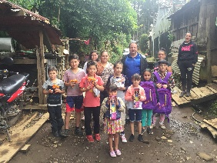**October 31st - Heading to Costa Rica**

On October 31st I head back to Costa Rica! This is so exciting! Our plans to go back to Costa Rica were shut down years ago when Covid hit, but now is the time to return. We will head up to visit the poor family we had visited with previously in the mountains.

We will also be visiting families in the village of Puntarenas and sharing the gospel with the families of the fishermen there. In Puntarenas there is a bridge, and I remember the people calling what’s on the other side of this bridge “Hades”. The reason is that there is so much spiritual A picture containing floor, indoor, building, table
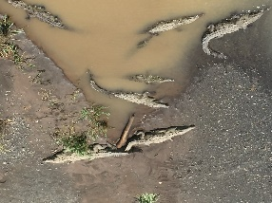darkness on the other side. Fortunately, there is a church planted on this side of the bridge. People from the spiritually dark side are able to cross over this bridge to attend church. While we are visiting this area we hope to take a boat from there and go to the nearby islands to share Jesus there, too!

I was in a conversation with Brother Steve Jones and he mentioned another bridge in Costa Rica that we will be crossing over, the Tarcoles Bridge. The Tarcoles river is full of crocodiles. The Lord spoke to my heart that we would preach from this bridge. People from around the world stop to tour this bridge. Last time we were here we ended up being interviewed by a television news station. We still need a breakthrough with finances for this trip. We know the Lord will provide! What an opportunity to see the faithfulness of the Lord!

**Thank You**

We want to thank all of you for your prayers and partnership! The Lord has been so faithful to provide every month! We have been amazed! The Lord is changing lives everywhere He sends us to go! All of you are a huge part! We love all of you so much!

**To make a donation, checks can be written to Go and Declare Inc. and mailed to 1117 Colbert Avenue, Pensacola, FL 32507. Folks can also give by clicking on the donate button on our website, www.goanddeclare.org or at any of the app links listed below. Our Square link is specifically set up for recurring donations, which is our biggest need! Believe with us for our greatest month yet as we operate on a limited budget! What an opportunity to see the faithfulness of God! He is good all the time!**

[Go and Declare, Inc - Go and Declare Inc (square.site)](https://checkout.square.site/merchant/MLHNGHTFXQKJA/checkout/DRXUUDXF7PNI57NZANVAS4AC)

<https://www.paypal.com/paypalme/goanddeclare>

[Pay $goanddeclare on Cash App](https://cash.app/$goanddeclare)

[Venmo | Go and Declare Inc](https://account.venmo.com/u/GoandDeclare-Inc)

Rudy R Waters II

Your servant to the lost, the least, and the last!

850-281-7555

[*www.goanddeclare.org*](http://www.goanddeclare.org)

*Go and Declare, Inc is a Florida Tax Exempt Non-Profit Corporation*