|  |  |
| --- | --- |
|  | Go and Declare, Inc.  Main: (850) 251-7555 Website: www.goanddeclare.org |

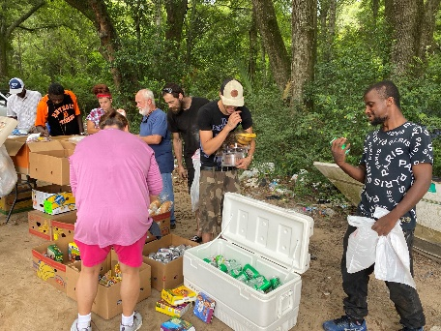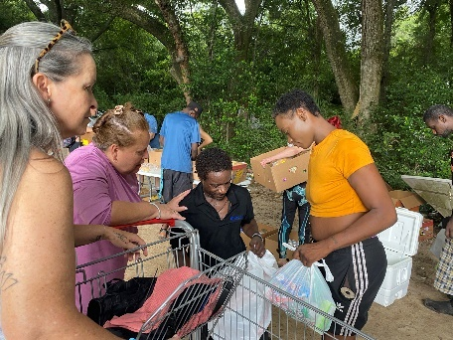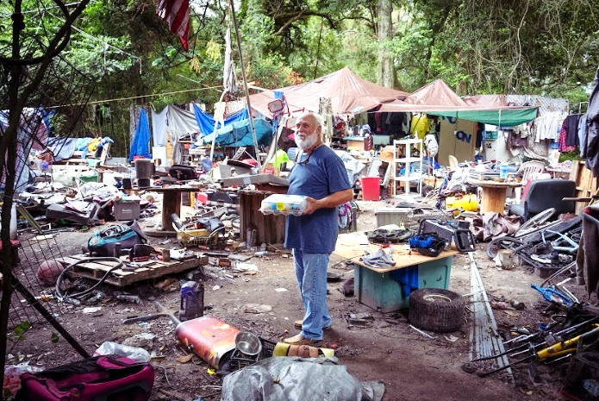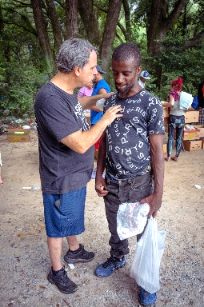

**Homeless Outreach Pensacola, Florida**

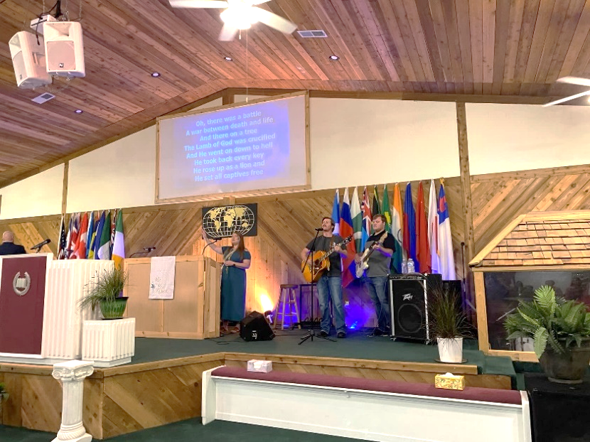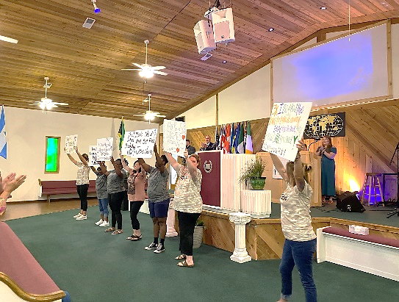Praise Jesus! This was a wonderful time of meeting the spiritual and physical needs of hurting people! The Lord provided the outreach team with all kinds of groceries including fresh produce items from the Freedom Church storehouse to bless these precious homeless people with! We didn’t have much time before the down pour of rain, but the Lord did a quick work!

**Ministers Conference Friendship, Tennessee**

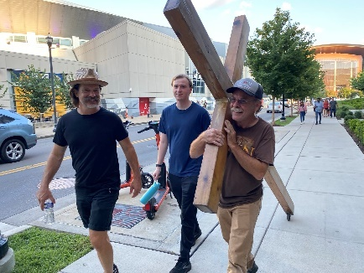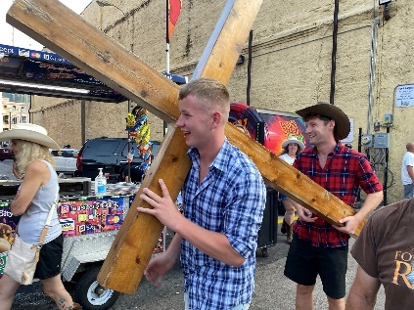John and I had an amazing time with our Emmanuel Church Family at the minister’s conference. We love them all so much! The Lord really moved in a powerful way. John was given a word of prophecy from Pastor Emmanuel from South Africa. John is still listening to the prophecy. He’s very encouraged!

**Cross Carrying Outreach, Nashville, Tennessee** Nathan Liechty, Russell Corp, our son John Waters, and I carried the cross into downtown Nashville. We had kinds of people come up to us and ask what we were doing. We prayed for all kinds of people that evening. We led one of the homeless guys to the Lord and we had a divine appointment with a bunch of guys from Ireland! They followed us around and we let them carry the cross! They were pretty buzzed, but the guy in front let me pray for him and he promised me that in the morning he would read the gospel of John that I gave him!

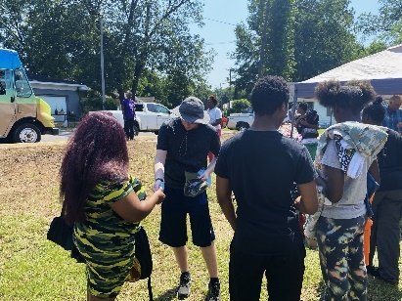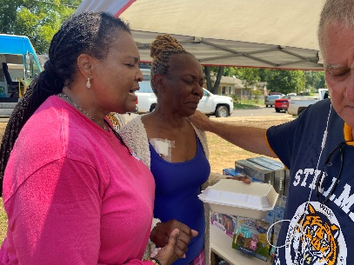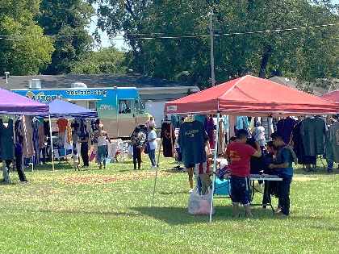**Outreach in West End Tuscaloosa, Alabama**

This was a powerful outreach in Tuscaloosa, Alabama. We had so many folks come for prayer that day! Pastor Javine shared with us about a shooting that happened not too long ago right down the street. He believes that the Lord was healing people from the trauma as they came to the property for free tacos, clothes, and other items. Folks were weeping in the presence of the Lord as the team prayed for everyone that came for prayer. Jesus showed up at West End Tuscaloosa! What a very special day!

**We Are Living in Exciting Times! Things Are Getting Very Busy!**

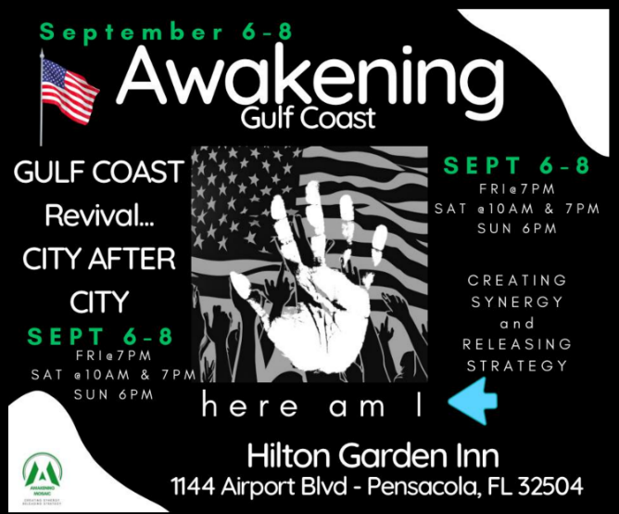Praise Jesus! We have raised enough funds for airfare for the Costa Rica trip Starting October 31st. With the airfare secured, we are now raising funding for lodging, traveling expenses in Costa Rica, food, and the finances to purchase supplies for the poor families in the mountains. I remember the last time we went the family we visited hadn’t had any food to eat in several days. We showed up at the right time. The team will be traveling to visit Youth Reach Costa Rica. Also, we will be visiting the fishing village of Puntarenas and on one of the islands and will be sharing the gospel, praying for the sick, and praying for folks to receive the baptism of the Holy Spirit! This is exciting! This will be the first time I will be going back since Covid hit! I need to raise around $2000 dollars before October 31st. Jesus is faithful!

Also, we will be busy reaching the lost in Pensacola. I was asked to lead a team to reach the lost during Awakening Gulf Coast, a convergence of churches gathering on Sept. 6th-8th. This is exciting!

Richard and I will be with our family our Southside Christian Center family in Caneyville, KY. Sept. 13th -15th.

October 12th-13th Richard and I will be with our House of Refuge Family in Picayune, Mississippi. We are excited to see both our Caneyville and Picayune families. We love the body of Christ! More to come!

**With Many Tears, We Thank You**

We are so amazed at what the Lord has been doing every month! Every month is unique and special! Lives are being changed wherever the Lord has been leading. You all are a huge part of every life that has been changed by the presence of the Lord! With many tears, we thank you all so much! We love you all so much and we are praying for every one of you!

**To make a donation, checks can be written to Go and Declare Inc. and mailed to 1117 Colbert Avenue, Pensacola, FL 32507. Folks can also give by clicking on the donate button on our website, www.goanddeclare.org or at any of the app links listed below. Our Square link is specifically set up for recurring donations, which is our biggest need! Believe with us for monthly partners as we operate on a limited budget! What an opportunity to see the faithfulness of God! He is good all the time!**

[Go and Declare, Inc - Go and Declare Inc (square.site)](https://checkout.square.site/merchant/MLHNGHTFXQKJA/checkout/DRXUUDXF7PNI57NZANVAS4AC)

<https://www.paypal.com/paypalme/goanddeclare>

[Pay $goanddeclare on Cash App](https://cash.app/$goanddeclare)

[Venmo | Go and Declare Inc](https://account.venmo.com/u/GoandDeclare-Inc)  Rudy R Waters II

Your servant to the lost, the least, and the last!

850-281-7555 [*www.goanddeclare.org*](http://www.goanddeclare.org)

*Go and Declare, Inc is a Florida Tax Exempt Non-Profit Corporation*