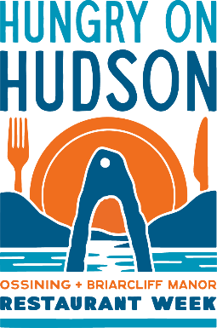
DINNER (Friday-Saturday)

$44.95

Appetizers (Choose 1)
Homemade Empanadas (4) (Choose beef, buffalo chicken, bean with cheese, mojo pork)
Polenta Bites with Tomato Jam

Entrée (Choose 1)
The Cuban
Mojo pork, mustard aioli, Swiss. Pickle, ham ciabatta bread, Served with fries

Pasta Bolognese
Rigatoni pasta with homemade meat sauce

Shrimp Scampi Pasta
Jumbo shrimp, pappardelle, scampi sauce, arugula

Veggie Fiesta Bowl (V, VG)
Black beans, watermelon radish, tofu, carrots, roasted red peppers, tomato jam, white rice, Greek Goddess dressing

Dessert (Choose 1)
Warm Chocolate Chip Skillet
Homemade Banana Pudding

