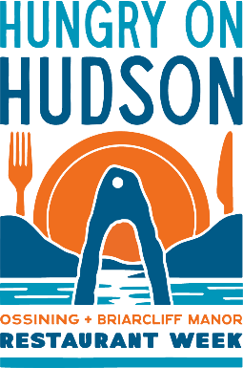

BRUNCH (Wednesday-Friday)

$34.95

Appetizers (Choose 1)
Ricotta Blueberry Poppers with Lemon Curd
Polenta Bites with Tomato Jam

Entrée (Choose 1)
Avocado Toast
Avocado, lemon pearls, watermelon radish, pickled onions, arugula, ciabatta bread

Southwest Chicken Salad
Fried chicken, bacon, tomatoes, avocado, cheddar cheese, croutons, homemade ranch dressing

Classic Eggs Benedict
Canadian bacon, poached eggs, hollandaise sauce on a homemade bacon biscuit, served with breakfast potatoes and greens

Dessert (Choose 1)
(4) Homemade Cookies (Chocolate Chunk, S’Mores, Salted Chocolate Chip, Snickerdoodle)
Homemade Banana Pudding

