

***CASA DE GLORIA, INC***

***20058 East Bell Road***

***Amite, Louisiana 70422***

**December 2022**

**2022 IN REVIEW**

**HAPPY BIRTHDAY JESUS!**

**January** We were blessed to be able to continue to support the local printing of the Jesus Story Books in Ethiopia where they are being used to evangelize the Muslim communities too; in Kenya and the Philippines.

Pat began the year with a special trip to San Andres Tuxtla, Veracruz, Mexico to officiate the wedding of Romina & Abraham, a precious young couple. We have known Romina for over 20 years. She is the daughter of Maya, Pastor of Casa de Gloria Centro and Ernesto Lopez. Pat also was honored to preach in Casa de Gloria's churches, visit homes to pray for the sick and to bring the message of salvation to families. 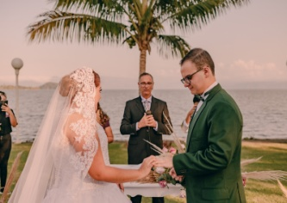 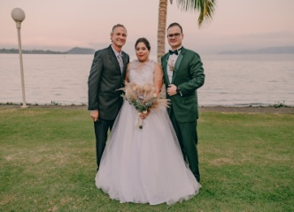 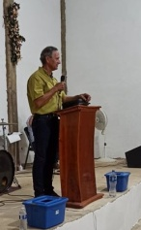 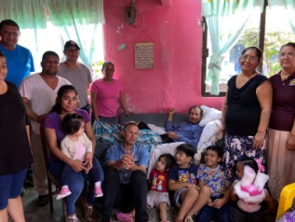 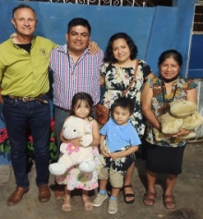

**April** Pat & I were blessed with an amazing all expense paid trip to Israel. We spent 10 days on a prayer journey through Israel walking where Jesus walked. Now, as we read the Word of God, the pages become more alive because we now have a visual and physical memory of what the bible is describing. We rode a camel at the Dead Sea, witnessed Jesus' empty tomb, rode in a boat on the Sea of Galilee where the wind encouraged the American Flag to wrap it's corners around the Israel flag. We also traveled to Samaria and Bethlehem where entrance to Israeli Citizens is dangerous. History was found at every step we took! 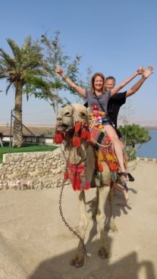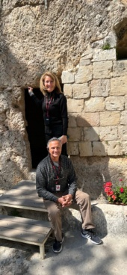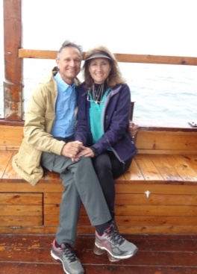

**May** was another fun month. Pat & I celebrated our 42nd Wedding Anniversary at the beach. We had a great weekend getaway relaxing to the sound of the waves and riding a few too!

Karen had the great privilege to participate with her oldest granddaughter, Lailah, in Studio 51's Grandmother Granddaughter recital.

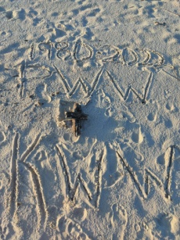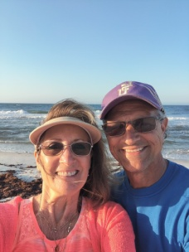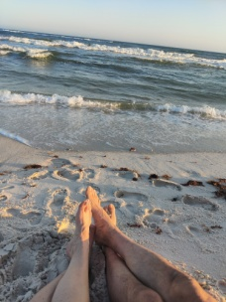 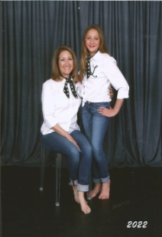 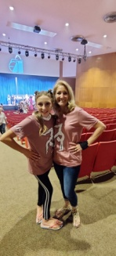 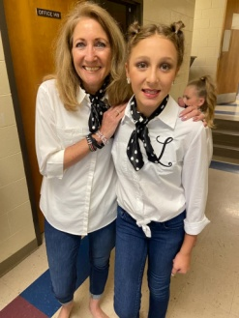

**July**  Ashley and I continued our horseback riding adventures into four more states. We rode in Ohio, NC, SC, and TN on our way to a weekend at Breyerfest 2022.

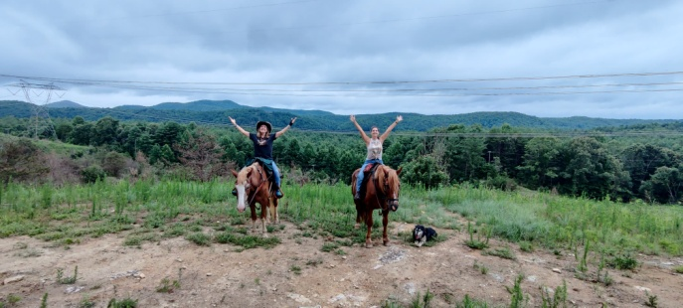

In **August** our entire immediate family united to go on a quiet tour of the Louisiana Swamps. It was quite the feat to get everyone's active schedules blended into one free day, but the Lord did it! Have you ever seen an alligator leap for marshmallows?

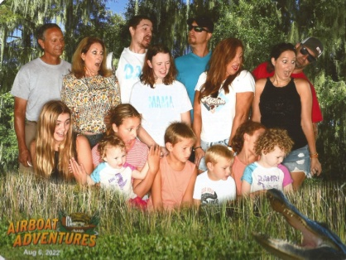 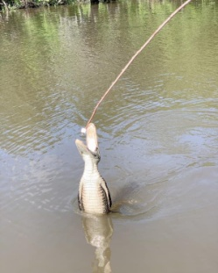 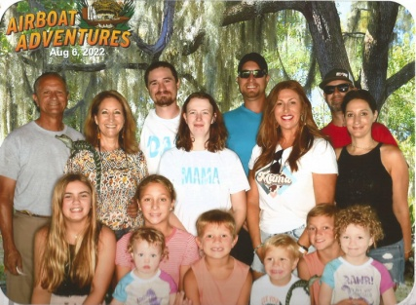 **October** we took advantage of the receding waters of the Mississippi to experience a once in a lifetime experience of walking on the 1915 sunken Brookhill Ferry Boat and under the hull of the USS Kidd ship!

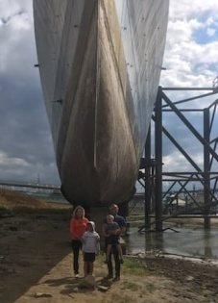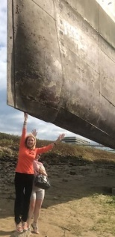 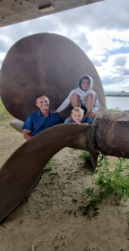 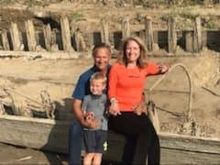 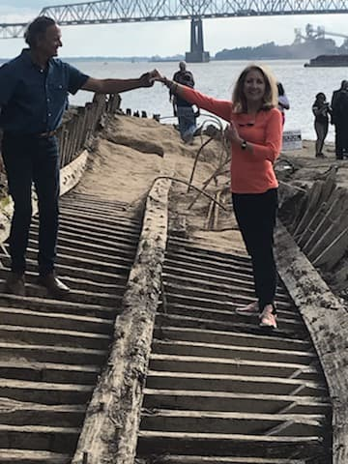 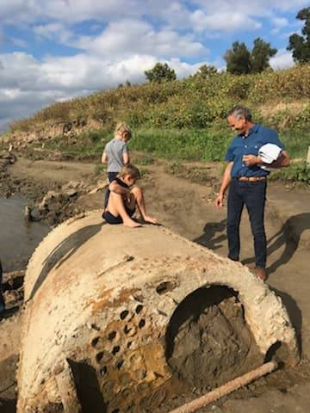

**November** is our annual fundraiser garage sale. We had not one but two garage sales and both were cold and got rained out. We had not one but two flats on the large trailer. But God in His mercy and grace honored our efforts!

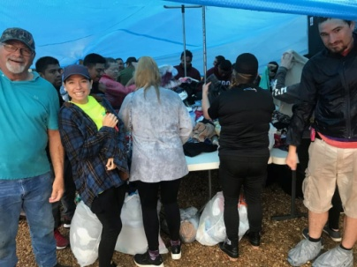 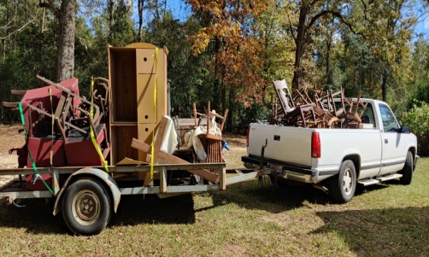 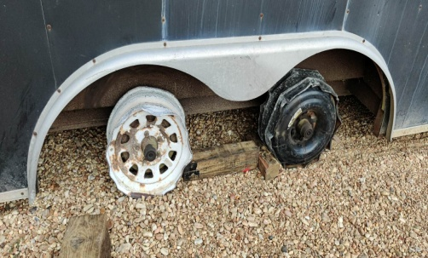

100% of the proceeds this year will go to buy The Jesus Story Books in Taglog and English and go to help our friends in Masaii land to provide hay/food for their cattle who are dying due to the severe drought affecting all of Kenya. The Masaii are grateful for the well that Commission Mankind put down last year. Jeremiah exclaims that without that wonderful source of water, all of his cattle would have died. He has lost over 25 thus far. It is costing him $1500 a month to feed his herd. He had to sell his healthy cattle to help feed the weak ones. Would you also consider helping to feed. Tsavo National Park in Kenya have lost to date 110 elephants, 32 buffalos due to the severity of the drought. https://tsavotrust.org/109-elephant-killed-by-drought-in-tsavo-this-year-the-initialising-slide-down-a-slippery-slope/

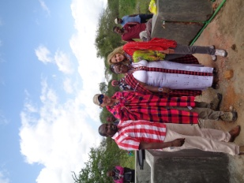

**December** Throughout the upcoming new year please consider supporting the printing of The Jesus Books or help this Massai family in Kenya sustain their animals through this horrific drought. We have created our very own web domain at https://casadegloriaministry.com and it is now set up to receive your donations. Just earmark how you would like your donation to be used and we will see that your seed is planted in good soil! **Or Checks can be mailed to our Home Base address: 20058 East Bell Road, Amite, LA 70422.**

There are also several ways you can help support CDG through the year at no cost to you. **AmazonSmile** is one simple way. Click on [smile.amazon.com](https://smile.amazon.com/?ref_=smi_se_saas_lsmi_smi) and when you shop online AmazonSmile will donate 0.5% of your eligible purchases to Casa de Gloria, Inc.

**Charity.Ebay.com/charity/i/Casa-de-Gloria-Inc/294177** is another way. You can now shop and even sell all year round with a purpose as you choose Casa de Gloria, Inc in your Charity Search. http://www.charity.ebay.com/charity/i/Casa-de-Gloria,-Inc./294177 via @eBay4CharityUs

Please let us know if you happen to find one of our old newsletters. We are adding them to our newsletter archives on our newly created website. We have a few years missing but go ahead and enjoy reading about our adventures from 1997 to the present!

Have a very blessed Christmas and It is our sincere desire to wish you a very Merry Christmas. We pray for God’s favor and grace and health to be upon you during this time. Let us all remember the greatest gift, Jesus Christ! Be blessed!!

Forever Trusting in Him,

*Pat & Karen Warren*