

***CASA DE GLORIA, INC***

***20058 East Bell Road***

***Amite, Louisiana 70422***

**December 2023**

**2023 IN REVIEW**

**HAPPY BIRTHDAY JESUS!**

**February:** Pat accompanied by 4 men: Evangelist Jeff Frederick from Washington, IN, Chad Hillstrom, Chris Primes from Amite, LA and Mike Rogers from Hammond, LA. They landed in Veracruz, Mexico ministering to everyone God put in their path and they never stopped.

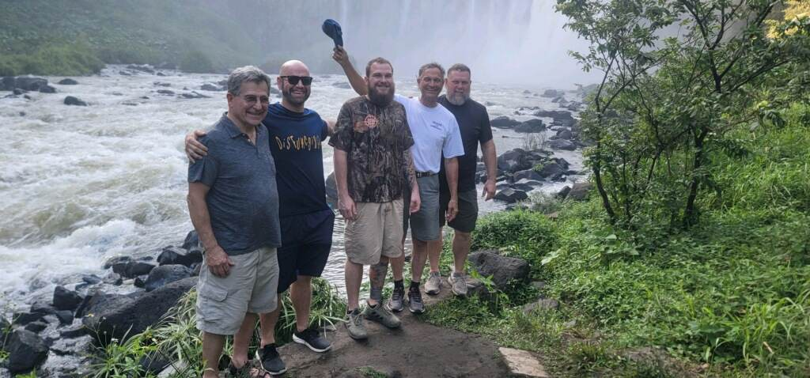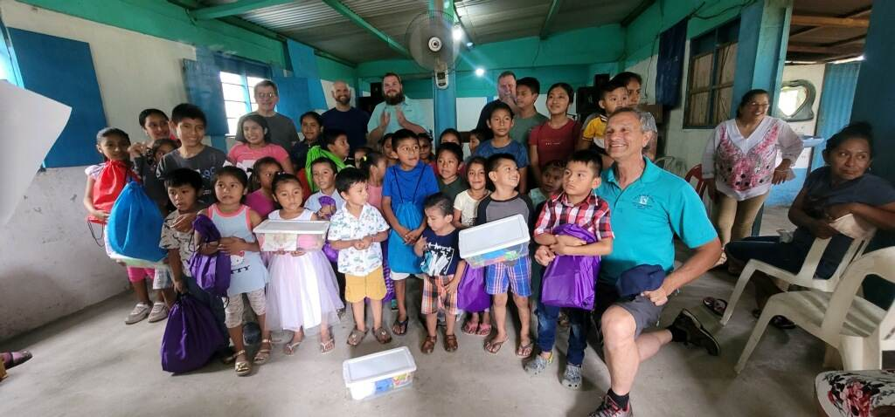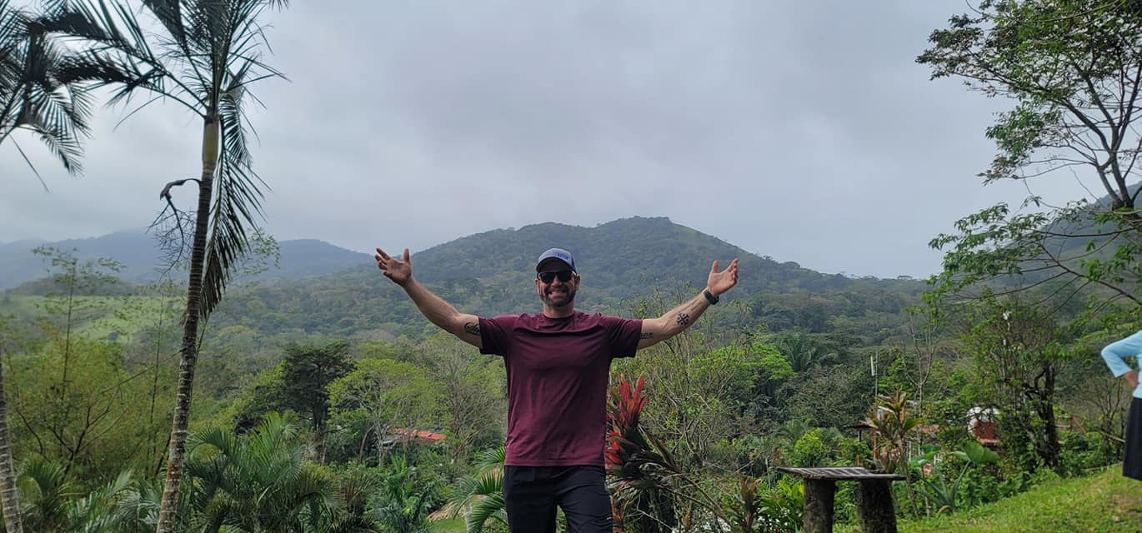

**May:** Pat & I celebrated our 43rd Wedding anniversary. We attended a wedding in Washington, Indiana. Our dear friends Jeff & Allyson Frederick's daughter's Abigail got married and Pat was asked to blow his Shofar at this God ordained occasion. Pat surprised me with a fantastic horseback ride through Historic Downtown Washington, IN. and we stopped for a picture in front of the church where the reception was held. This was the first time in 47 years of dating that he rode a horse with me!

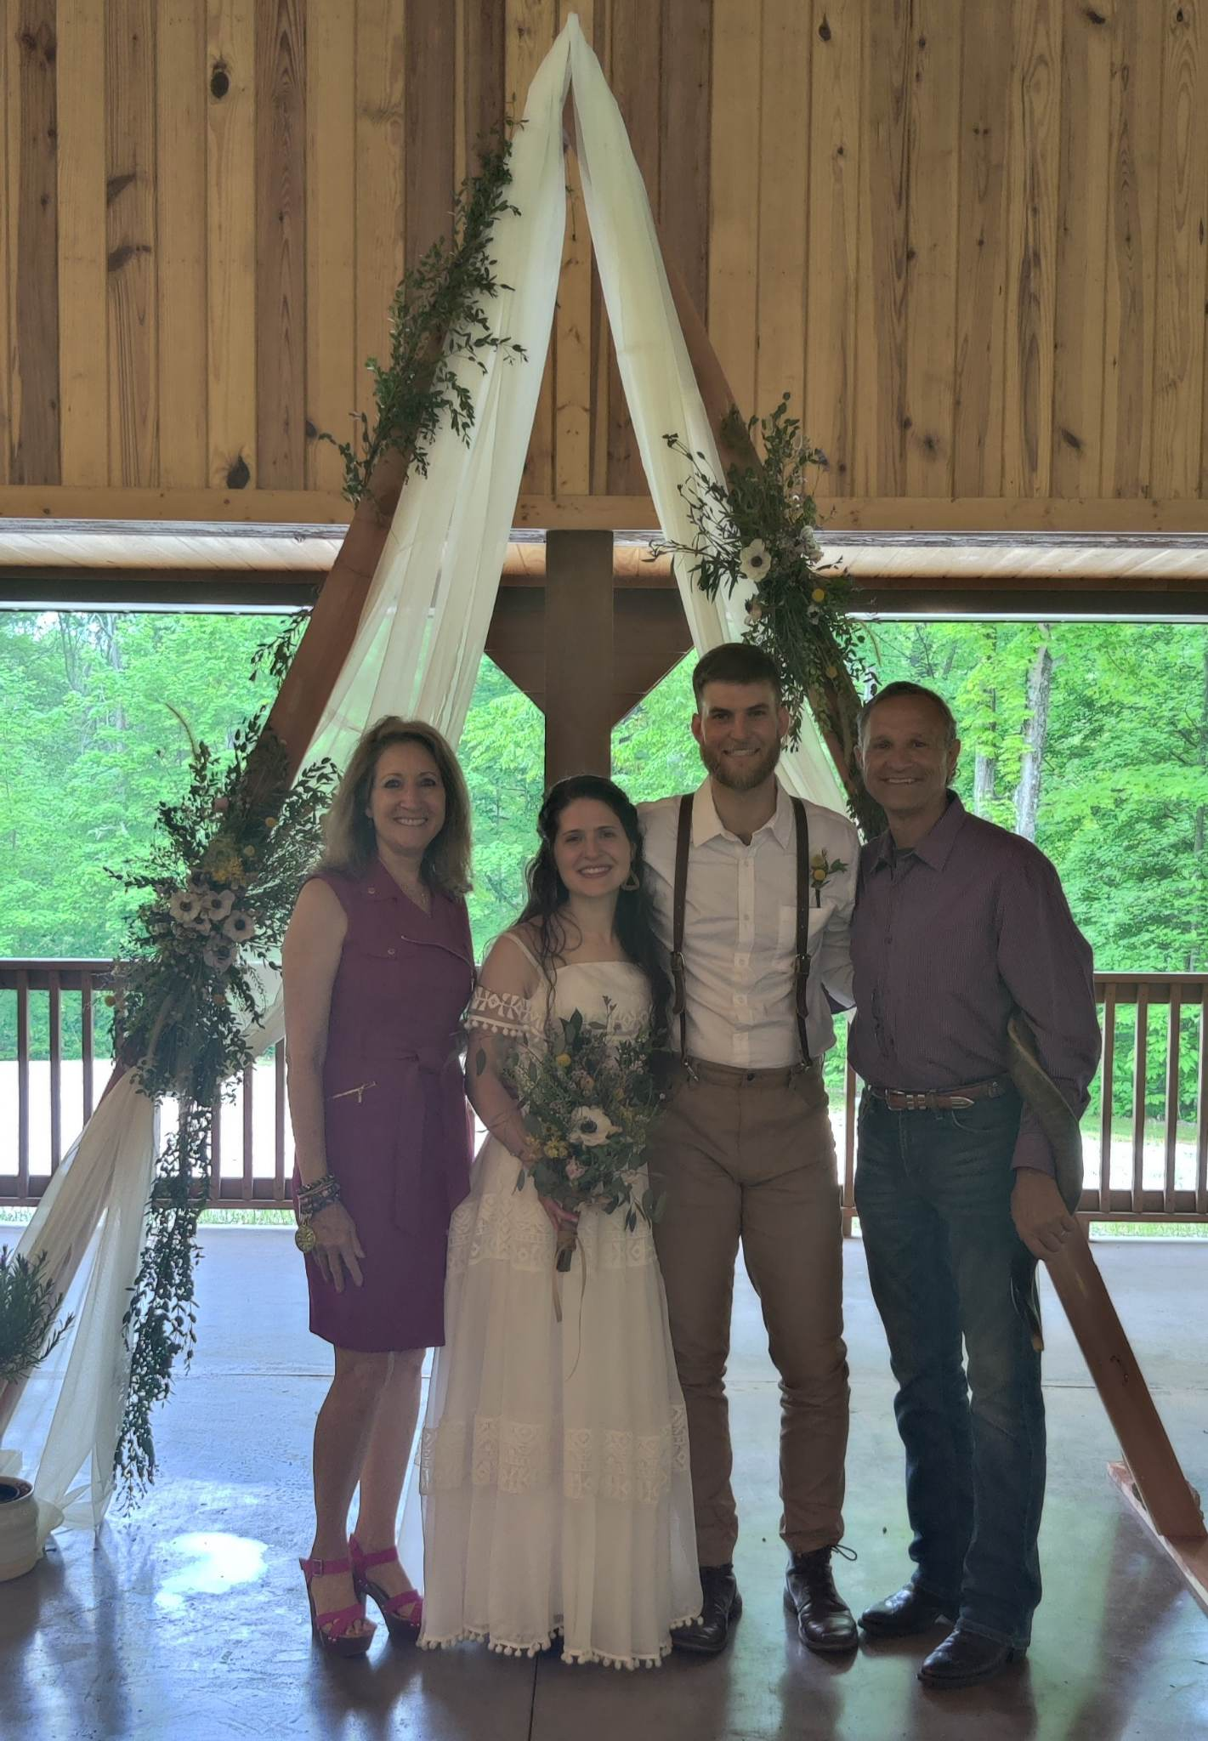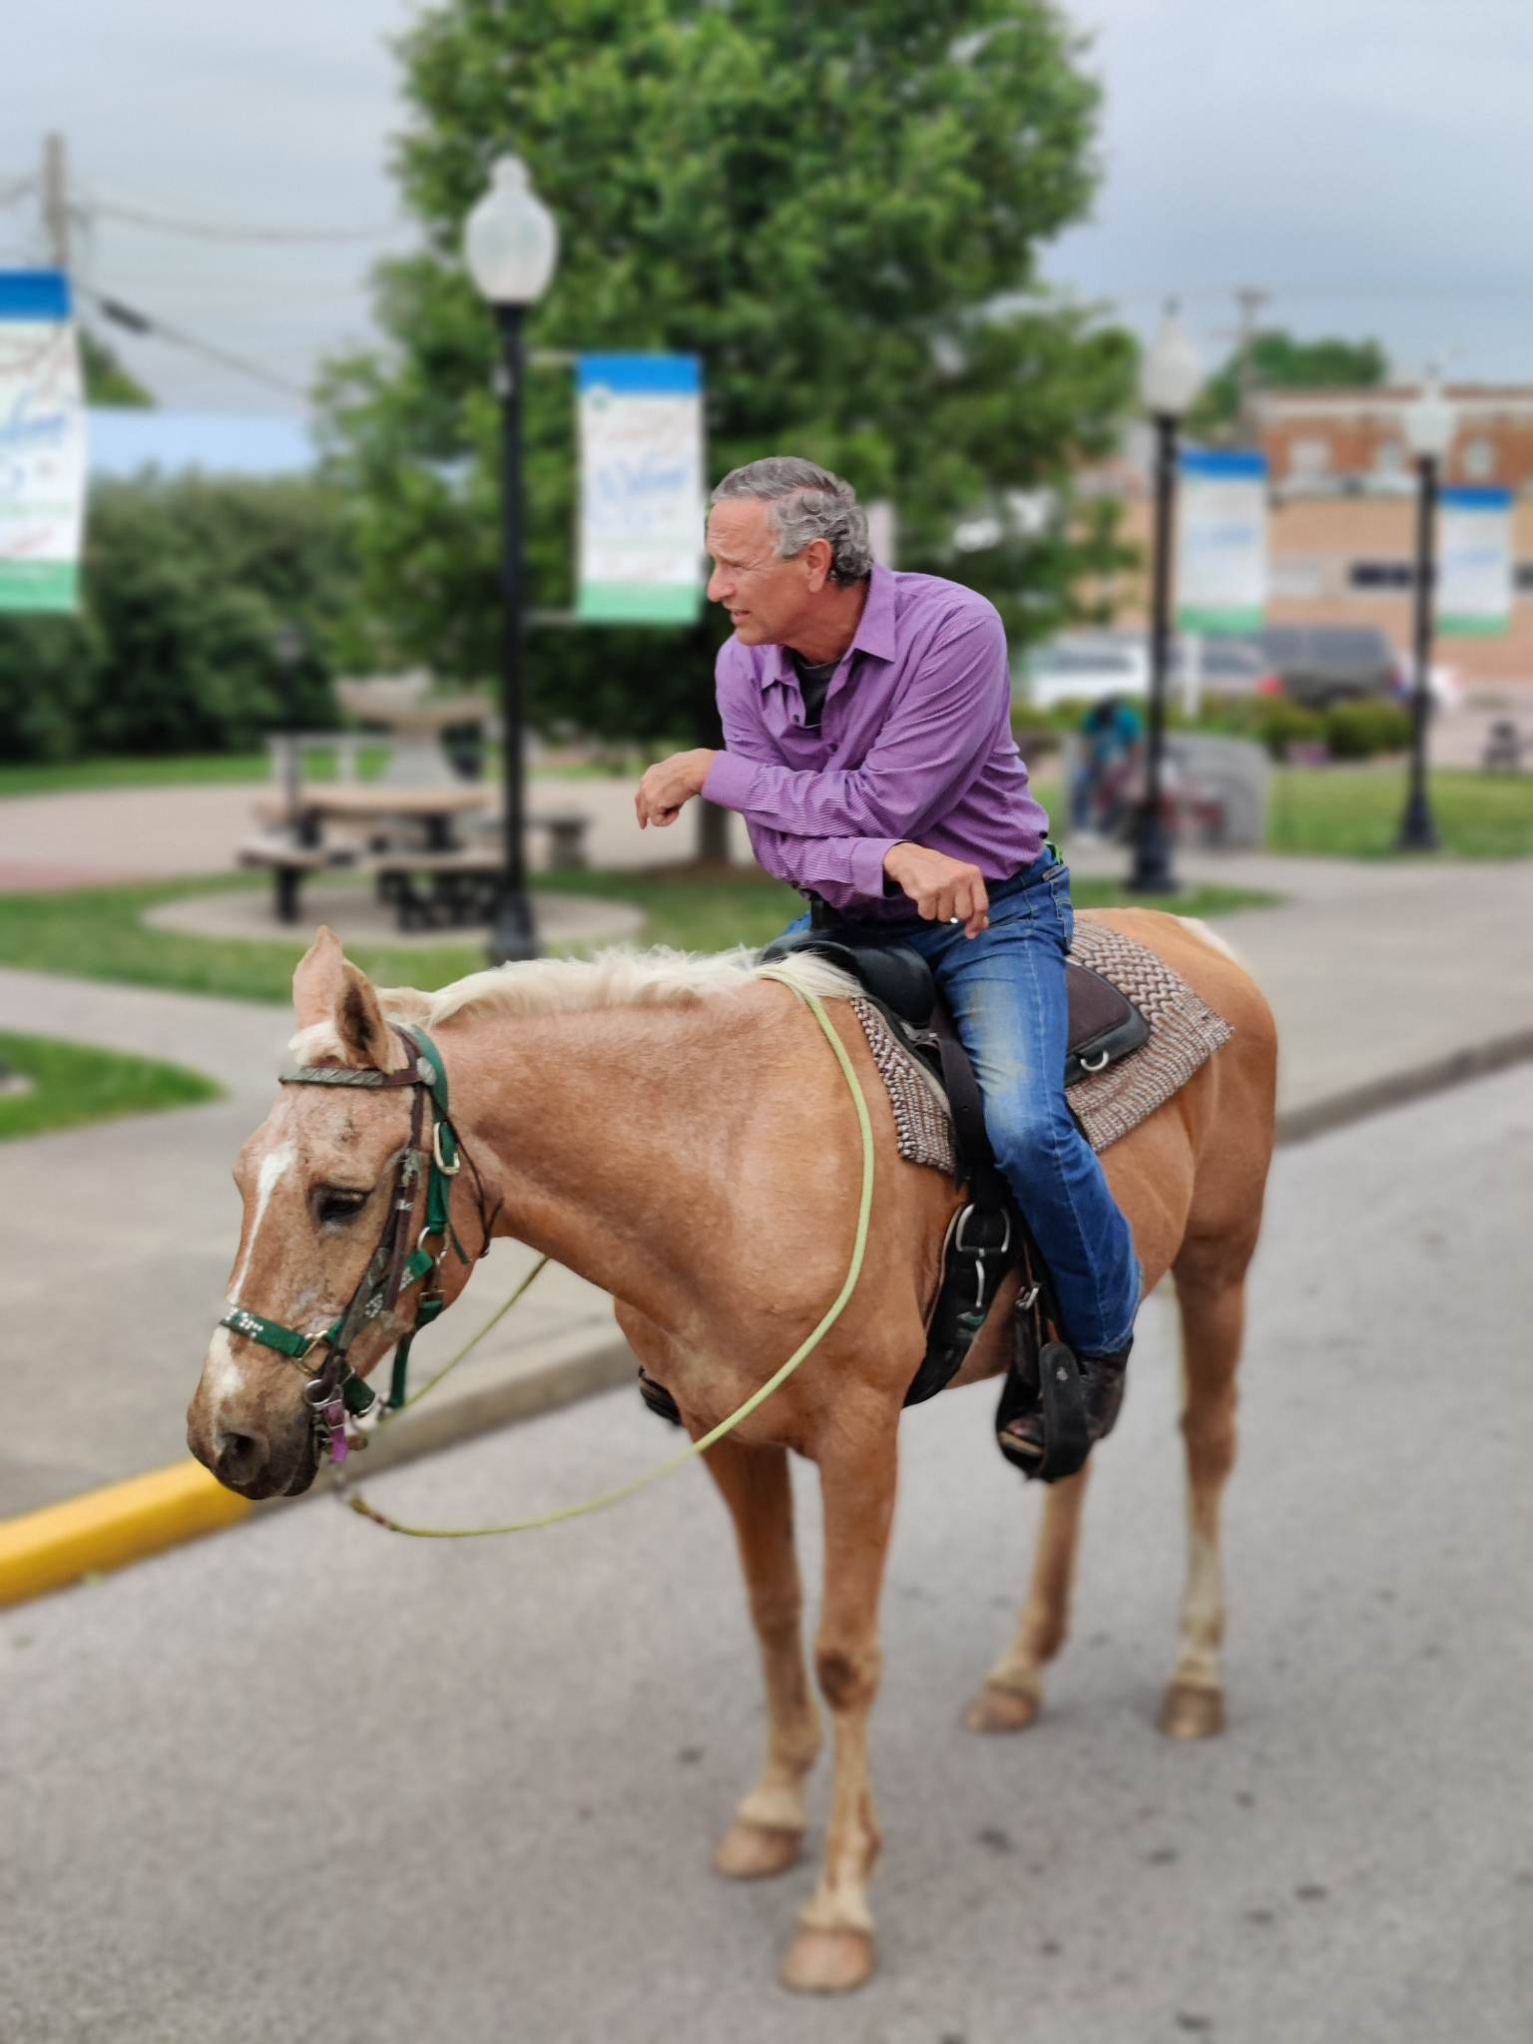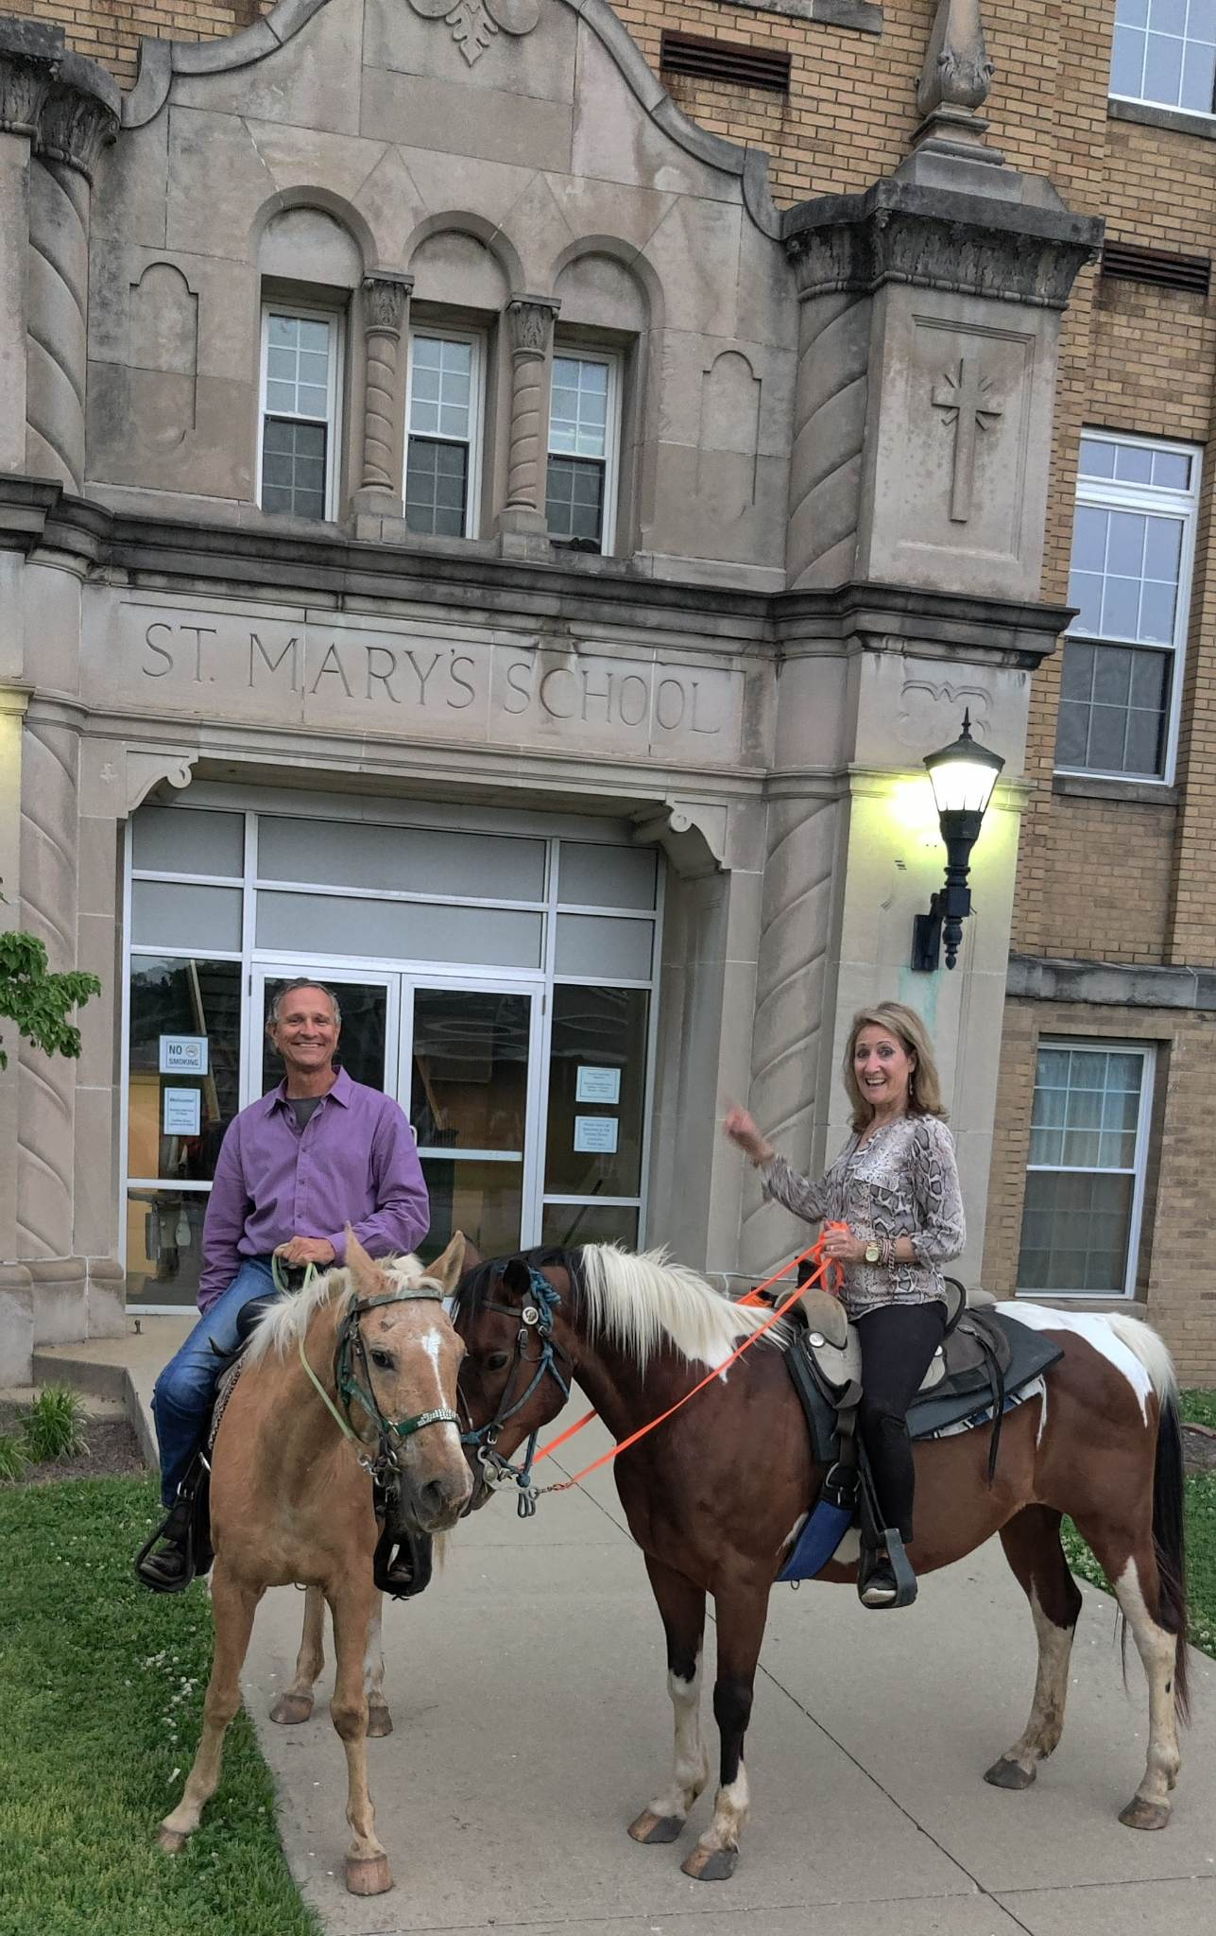

**September:** Pat and I were able to take his mother to visit her sister and family in Kenosha, WI. We were blessed to take in three more states of horseback riding adventures to help Karen continue her bucket list to ride a horse in every state. Karen was blessed to meet up with a childhood friend from Scott AFB, Forrest Degal, at the American Family Field Stadium to watch our beloved Cardinals play the Brewers on Thursday, and again on Friday when the Brewers played Pat's Cubs. Our oldest son Jacob and his wife Kayla and our oldest grandkids met up at the Friday game and surprised us with field passes to talk with our hometown boy and great left handed pitcher Wade Miley and also ride down the Mascot Bernie's Homerun Slide!

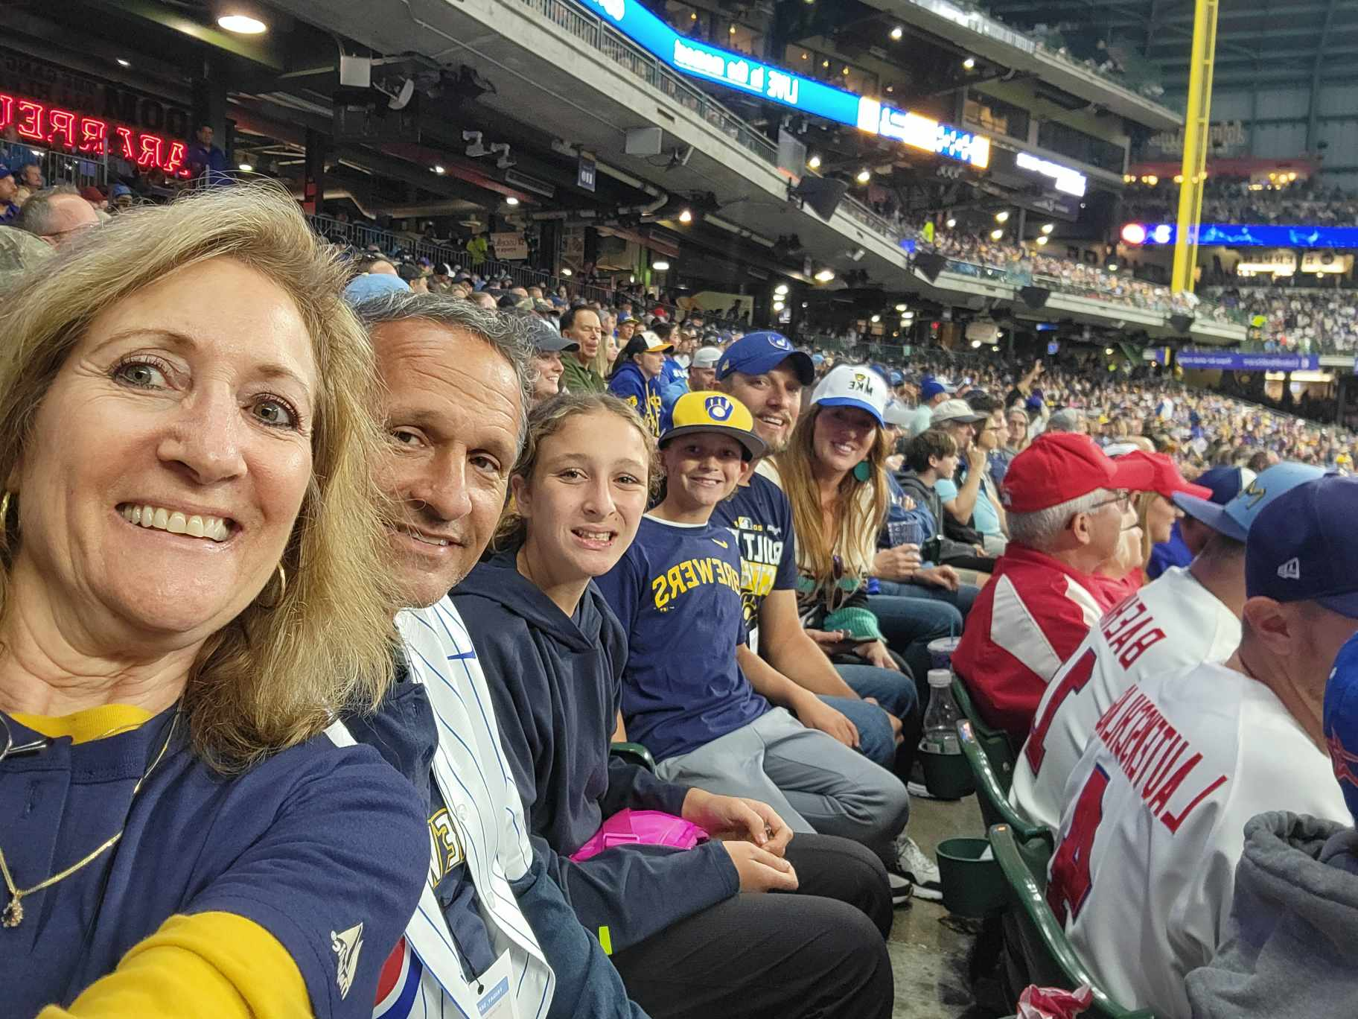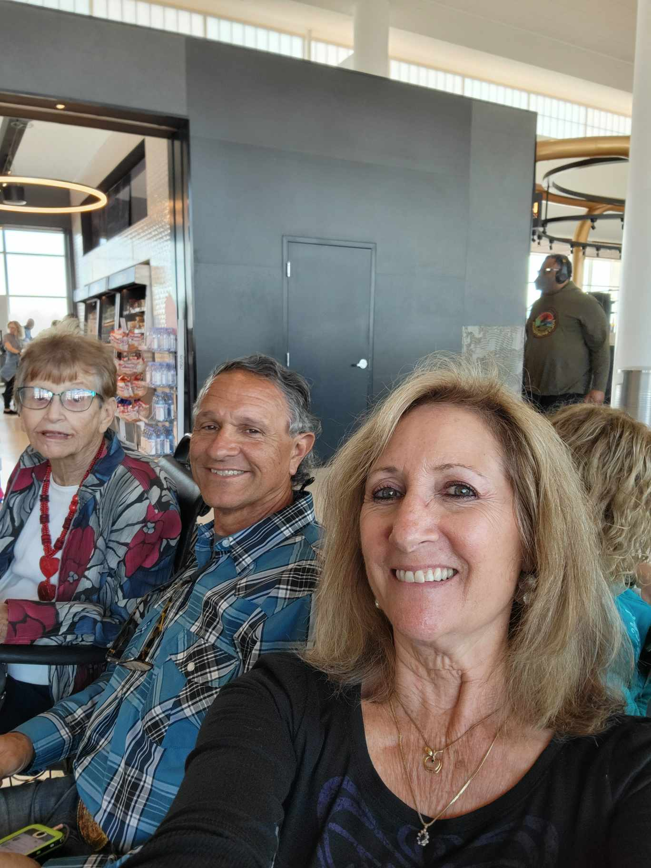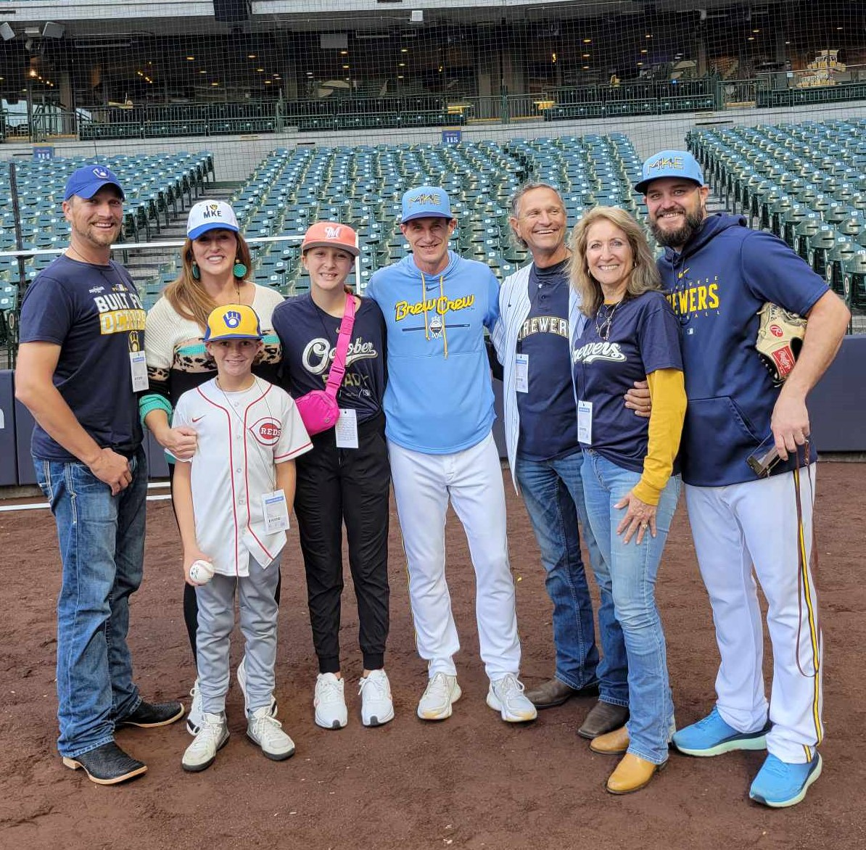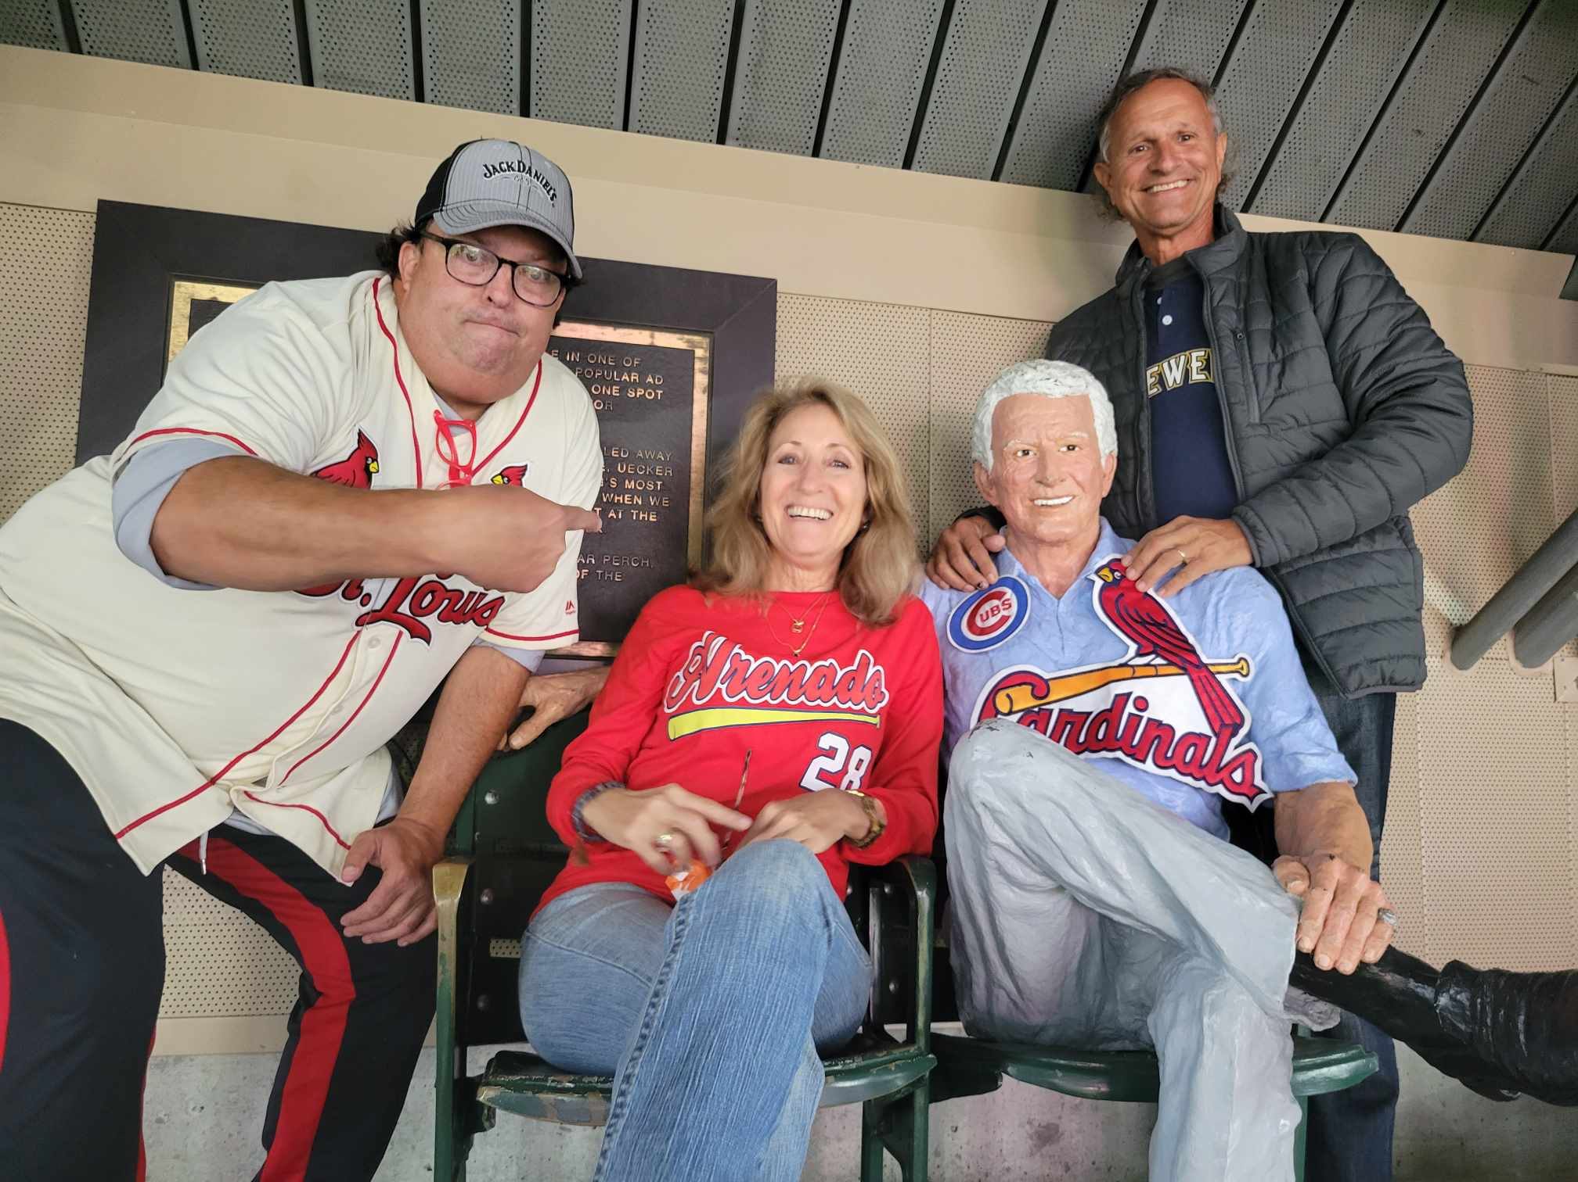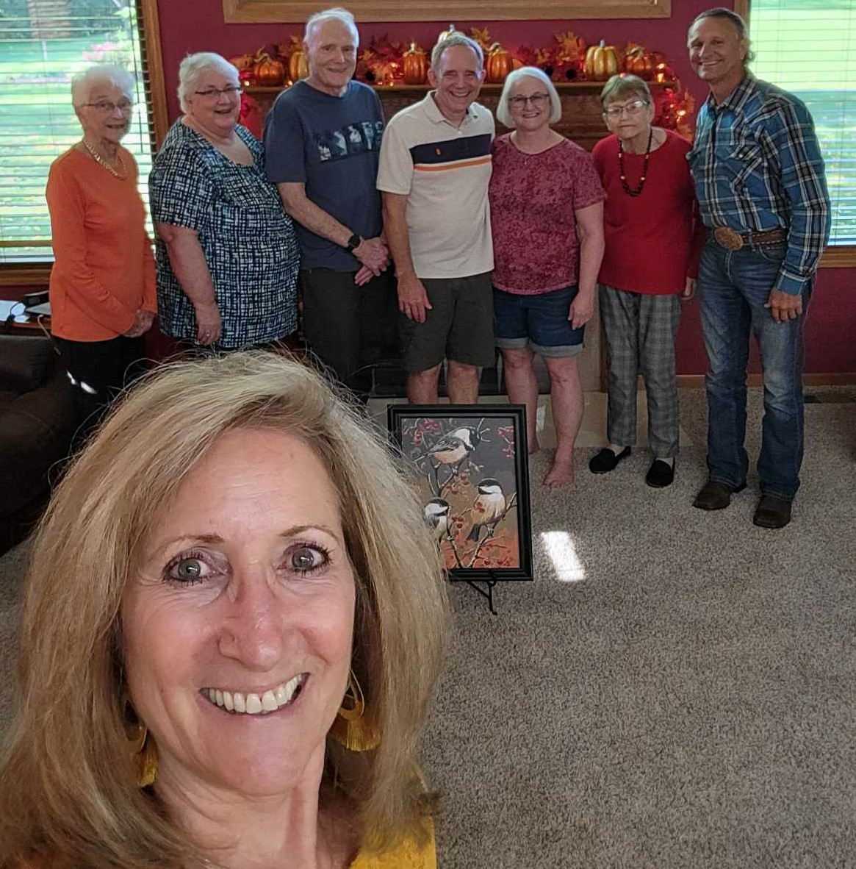

**November** is our annual fundraiser garage sale. 100% of the proceeds this year went tothe Matua Kimeu family in Machakos, Kenya. They are a family of 10 children, 4 girls and 4 disabled boys, ages 13 and 16 years old, 2 of their boys have since passed when they reached the age of 17 years old. Three of the girls have moved out of the house after getting married and the youngest is still at home with a young child. Their home has structural damage which is allowing the elements inside their bedrooms. God has used Casa de Gloria to rebuild them a 3 bedroom block home with a tin roof. Phase one is about complete and Phase II will include a bathroom and kitchen with a small covered pavilion for the handicapped boys to have a place to protect themselves from the elements. FYI: For only $34.00 USD a month you can feed this family every month.

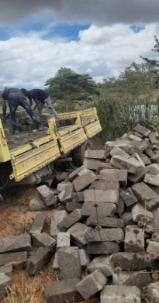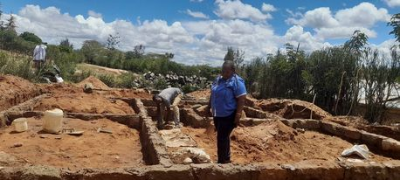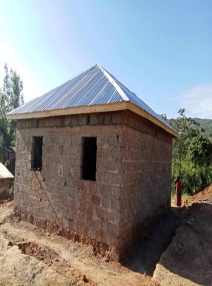Casa de Gloria also provided the finances to help print 10,000 The Jesus Story and Jesus in Me Books in Oromo language in Ethiopia. And were fortunate to assist with the burial of our beloved friend, Silvia from La Barra, Veracruz, MX. Miss her greatly!

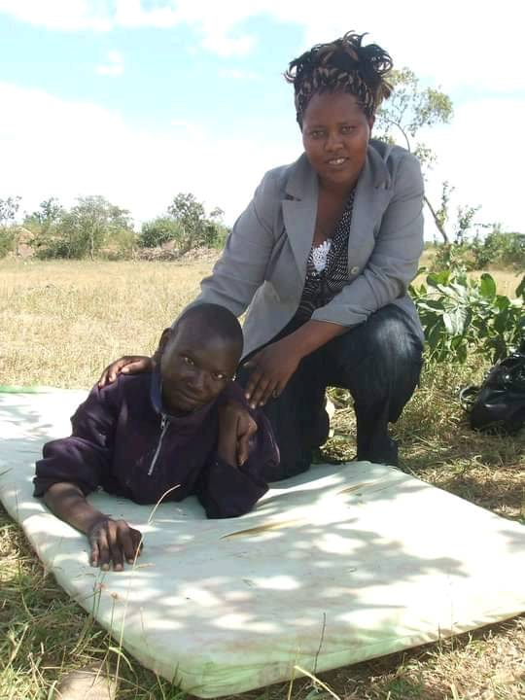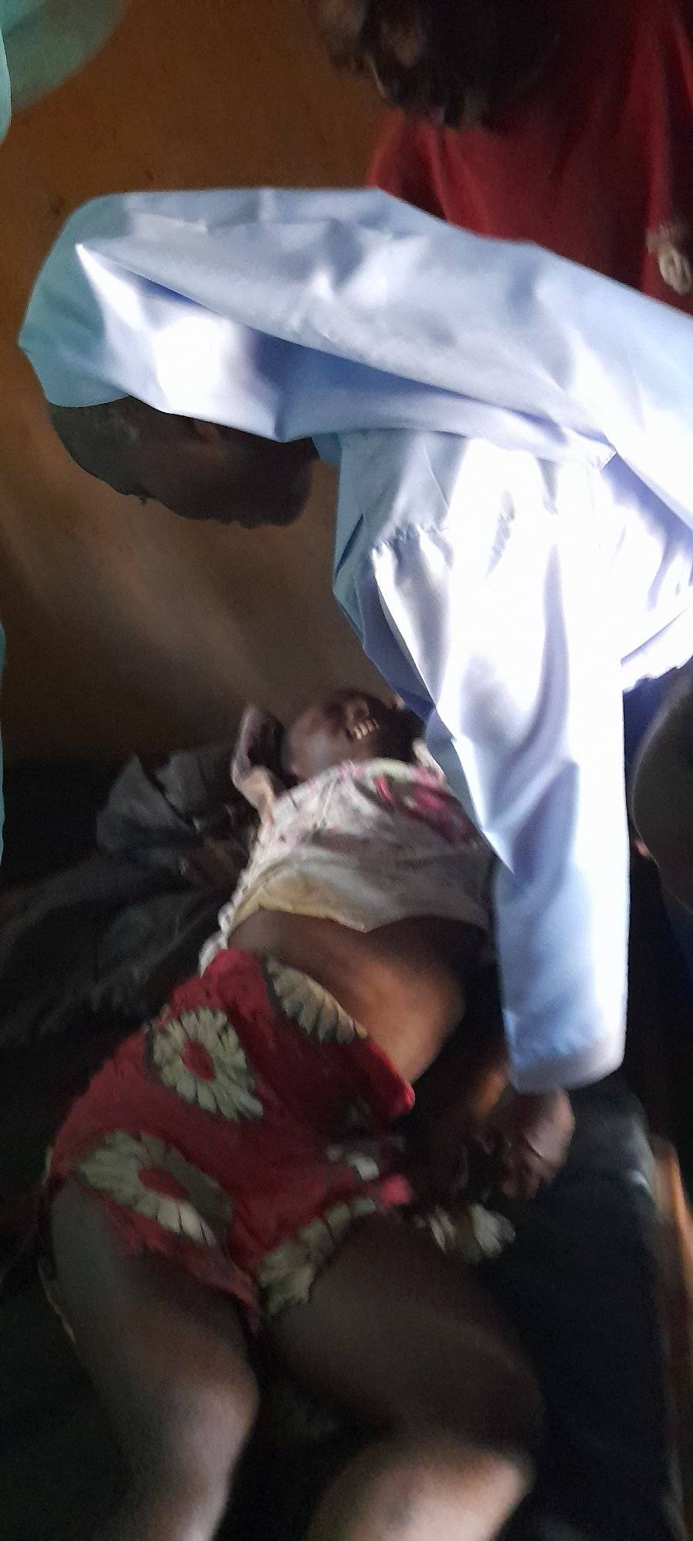

We were blessed with a visit from Karen’s childhood friend in Ethiopia who resides in California, Julie Creed and Scott Spencer. We went on a safari at Global Wildlife and saw some antebellum homes in St. Francisville. 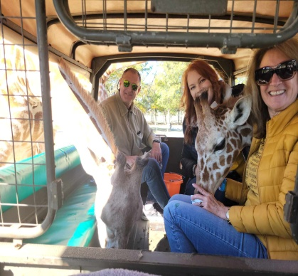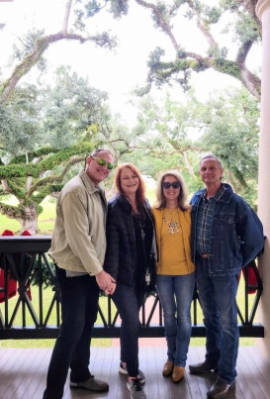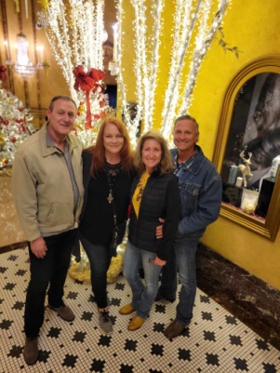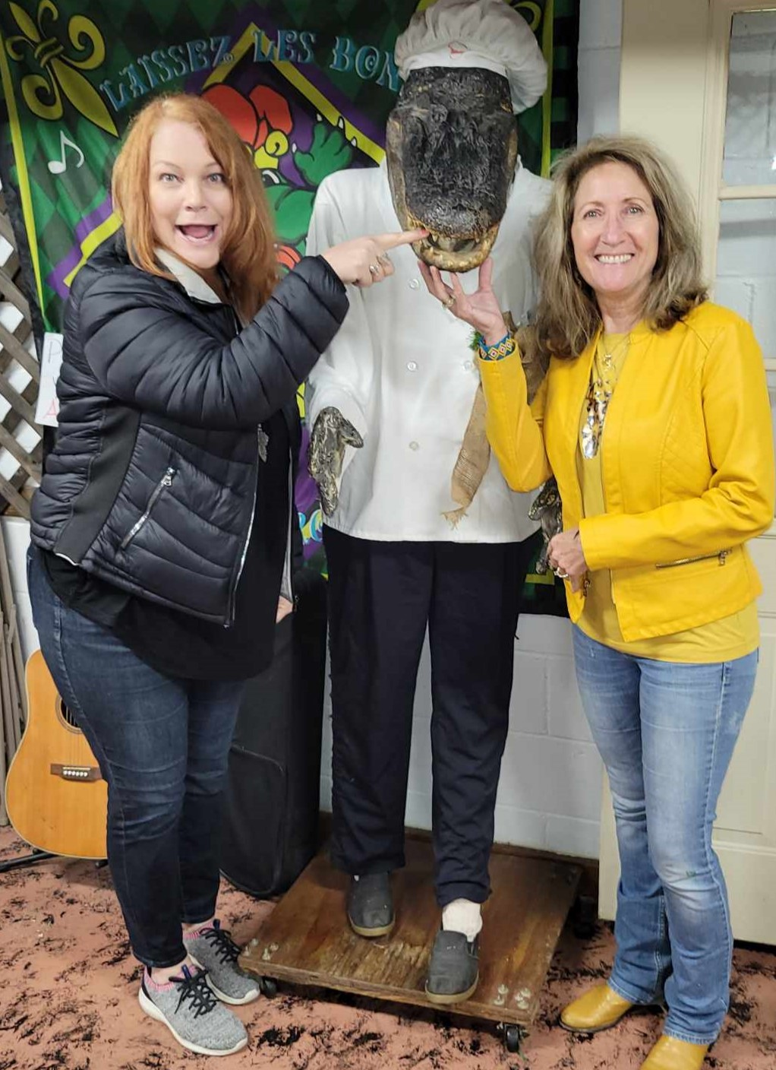

**December** Casa de Gloria church in San Andres Tuxtla Centro, Veracruz, Mexico will host Revive 2023 as they have for the past 14+ years. Pastor Troy Thomas and a small team will be in San Andres Tuxtla to preach the Good News, heal the sick and set the captives free. They have been faithful to “Go Ye" to Casa de Gloria since Revive #1.

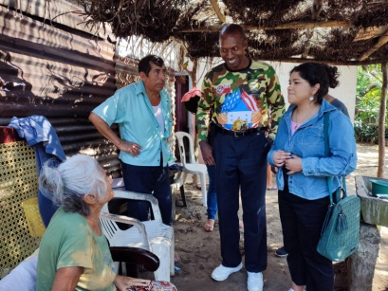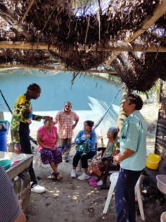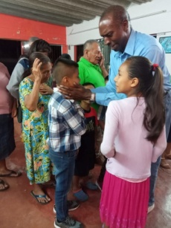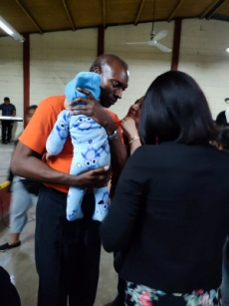

**We are excited to inform you that we have created our very own web domain at https://casadegloriaministry.com and it is now set up to receive your donations.** Just ear mark how you would like your donation to be used and we will see that your seed is planted in good soil!

**Or Checks can be mailed to our Home Base address: 20058 East Bell Road, Amite, LA 70422.**

Also, please let us know if you happen to find one of our old newsletters. We are adding them to our newsletter archives on our newly created website. We have a few years missing but go ahead and enjoy reading about our adventures from 1997 to the present on our website!

**Have a very blessed Christmas and remember Jesus is the gift that perfectly fits the size of every heart**.

We pray for God’s favor and grace and health to be upon you during this time. Let us all remember the greatest gift is Jesus Christ! Be blessed!! Forever Trusting in Him, *Pat & Karen Warren*