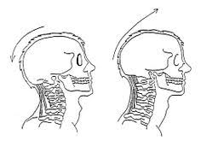
Back and Down or Forward and Up

The Alexander Technique

The Alexander Technique teaches us how to be present, how to focus, how to be easy in our bodies and minds, how to find good posture and how to balance movement and stillness. Alexander in Education helps children to learn more happily and effectively. It helps classroom teachers to more effectively manage themselves in the classroom and beyond. This helps to reduce, manage and even eliminate stressful situations.
The Technique is taught by verbal instruction and by gentle indications from the hands of the Alexander teacher. Touch of the pupil by the teacher is the clearest way to convey the principles of the Technique and is essential to the teaching. Alexander teachers are trained to use their hands in a thoughtful and safe way and are regulated by a professional body and a clear code of conduct.
Alexander in Primary Education has been developed over many years of work with children and classroom teachers and is exemplified by the system used at Educare Small School. It is effective because it is completely in accord with how we should naturally function in daily life and with how we learn.

