# Amalfi Barstool

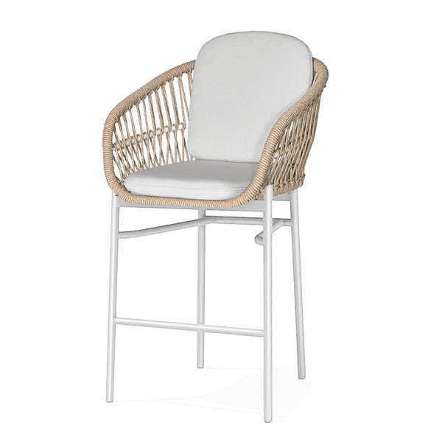

**SKU**: 1AC

## Product Summary

**Material:** Powder Coated Aluminum Tube with PE Wicker

**Finishes:**#31 Natural & #5 Black (coming summer 2023)



**Cushion SKU:** C1AC + Fabric

**Dimensions:** 43″ x 25″ x 25″