Amalfi Dining Chair

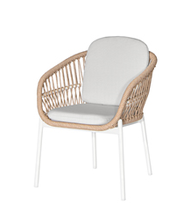
SKU: 1AC004

Product Summary
Material: Powder Coated Aluminum Tube with PE Wicker
Finishes: #31 Natural
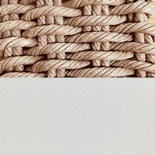
Cushion SKU: C1AC004 + Fabric
Dimensions: 25″ x 25″ x 31″

