# Amalfi Sofa

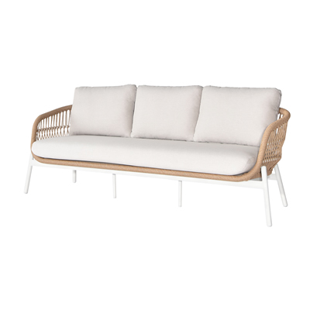

**SKU**: 1AC003

## Product Summary

**Material:** Powder Coated Aluminum Tube with PE Rope

**Finishes:**#31 Natural

**Cushion SKU:** C1AC003 + Finish #

**Dimensions:** 84″ x 32″ x 31″