Amalfi Loveseat
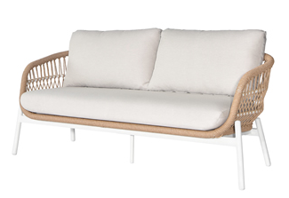
SKU: 1AC002

Product Summary
Material: Powder Coated Aluminum Tube with PE Rope
Finishes: #31 Natural
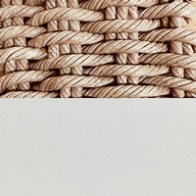
Cushion SKU: C1AC002 + Fabric
Dimensions: 71″ x 32″ x 30.5″

