Azalea II Arm Chair

SKU: 1A120C2

Product Summary
Material: Resin Wicker
Finishes: #8 Driftwood Flat & #18 Truffle
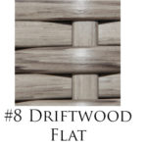
Cushions: CA120C2 + Fabric #
Dimensions: 23.5" W x 20.5" D x 33" H, Arm: 26" H
Stackable

