**Azalea II Chaise Lounge**

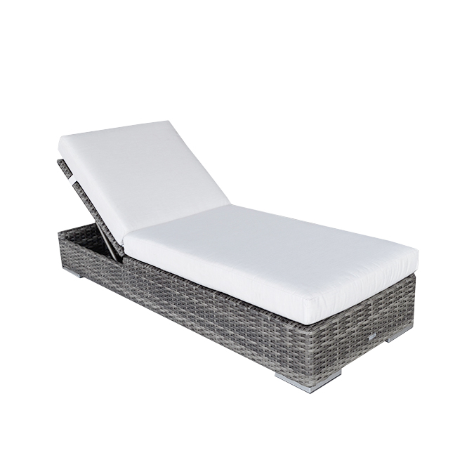

**SKU**: 1A116L

## Product Summary

**Material:** Resin Wicker

**Finishes:**#8 Driftwood Flat & #18 Truffle

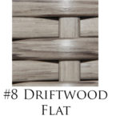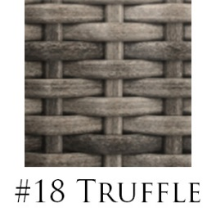

**Cushions: C1A116L + Fabric #**

**Dimensions:** 31" W x 82" D x 16" H (w/ cushion) 11″ H (w/o cushion)