Azalea II Club Chair

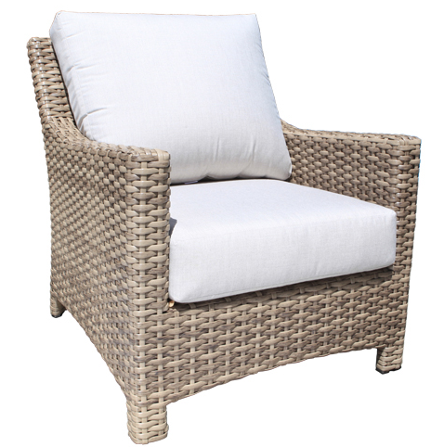
SKU: 1366F

Product Summary
Material: Resin Wicker
Finishes: #8 Driftwood Flat & #18 Truffle
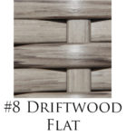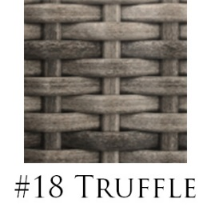
Cushions: C1366F + Fabric #
Dimensions: 30.5" W x 35" D x 32.5" H

