Azalea II Loveseat

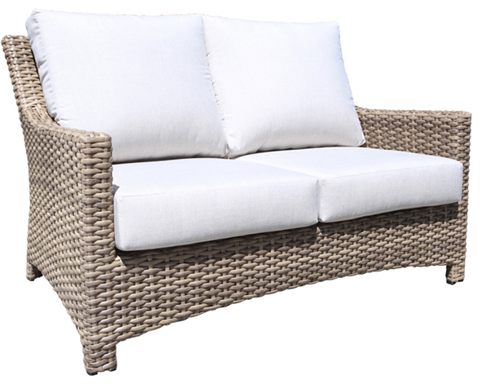
SKU: 1366B

Product Summary
Material: Resin Wicker
Finishes: #8 Driftwood Flat & #18 Truffle
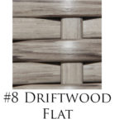
Cushions: C1366B + Fabric #
Dimensions: 53.5" W x 36" D x 33" H

