**Azalea II Ottoman**

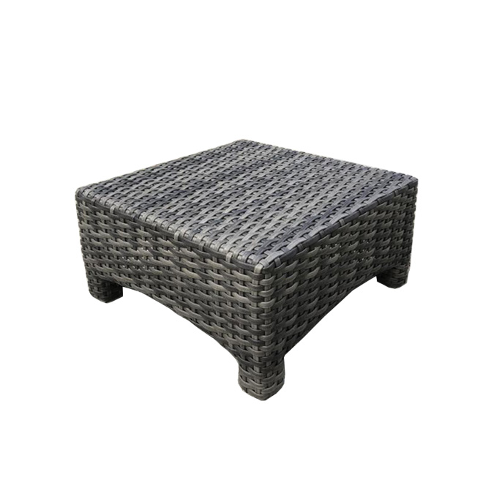

**SKU**: 1366O

## Product Summary

**Material:** Resin Wicker

**Finishes:**#8 Driftwood Flat & #18 Truffle

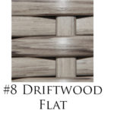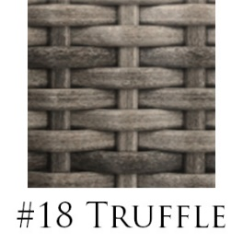

**Cushion SKU: C1366O + Fabric # (cushion included, but not pictured)**

**Dimensions:** 24.5" W x 24.5" D x 12" H (w/0 cushion)