Azalea Storage Coffee Table

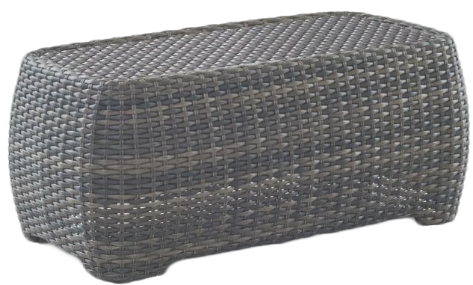
SKU: AZ36002

Product Summary
Material: Wicker
Finishes: #8 Driftwood Flat & #18 Truffle
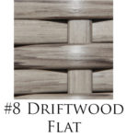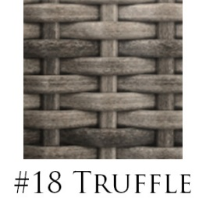
Item SKU: AZ36002+ Finish #
Dimensions: 46" L x 25" W x 20" H

