**Azalea Storage End Table**

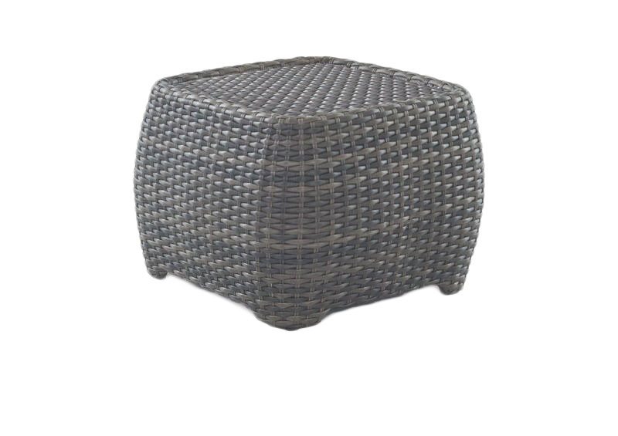

**SKU**: AZ36001

## Product Summary

**Material:** Wicker

**Finishes:**#8 Driftwood Flat & #18 Truffle

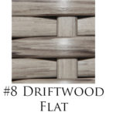

**Item SKU: AZ36001+ Finish #**

**Dimensions:** 26.7" L x 26.7" W x 20" H