Bali Club Chair

SKU: 1A195A

Product Summary
Material: Resin Wicker
Finishes: #30 Carbon
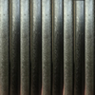
Cushion SkU: C1A195A + Fabric #
Dimensions: 30.5″ D x 30″ W x 26.5″ H

