**Bali Coffee Table**

**SKU**: 1A195D1

## Product Summary

**Material:** Resin Wicker

**Finishes:**#30 Carbon

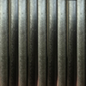

**Dimensions:** 22″ D x 40″ W x 16″ H