**Bali Dining Arm Chair**

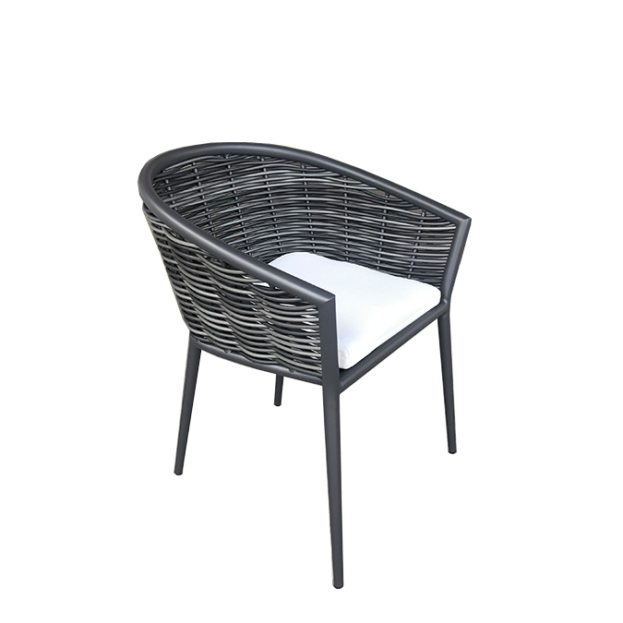

**SKU**: 1C288T6

## Product Summary

**Material:** Resin Wicker

**Finishes:**#30 Carbon



**Cushion SkU: C1C288-T6**

**Dimensions:** 25″ x 25″ x30″

Stackable