**Bali Dining Base**

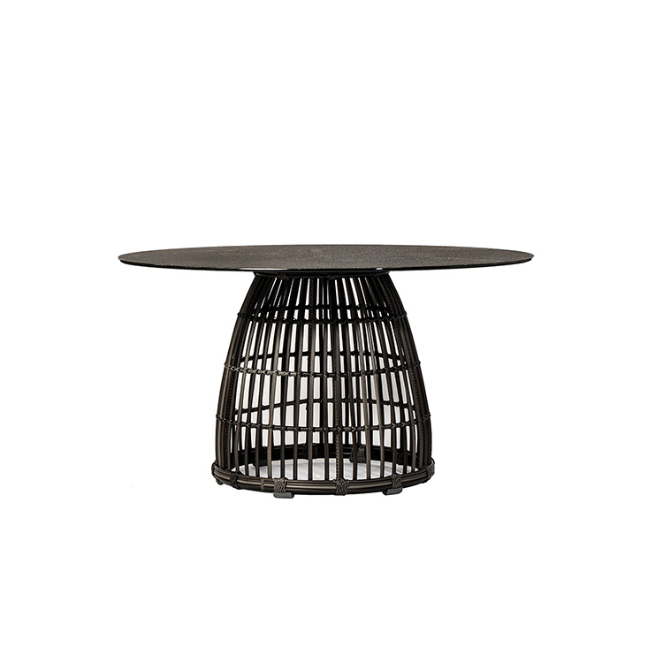

**SKU**: 1A195T2

## Product Summary

**Material:** Resin Wicker

**Finishes:**#30 Carbon



**Dimensions:** 24″ x 29″

Base Only