**Bali Ottoman**

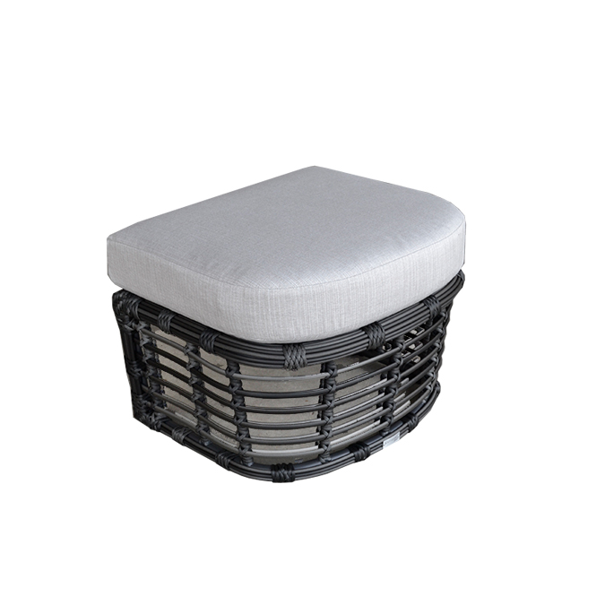

**SKU**: 1A195O1

## Product Summary

**Material:** Resin Wicker

**Finishes:**#30 Carbon

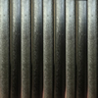

**Cushions SKU: C1A195O1 + Fabric # (cushion included, but not pictured)**

**Dimensions:** 20″ D x 24″ W x 16″ H