Bali Sofa

SKU: 1A195E

Product Summary
Material: Resin Wicker
Finishes: #30 Carbon
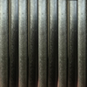
Cushion SkU: C1A195E + Fabric #
Dimensions: 30.5″ D x 71.5″ W x 26.5″ H

