Barbados Left Arm Facing Sectional

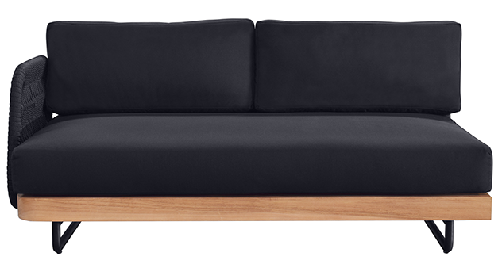
SKU: 1W-0064-00

Product Summary
Material: Tubular Aluminum/Rope/Teak
Cushions SKU: C1W-0064-00 + Fabric #
Finishes: Natural Teak, Black Rope
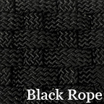
Dimensions: 56.2″ W x 28.7″ D x 24.4″ H

