**Barbados Square Ottoman**

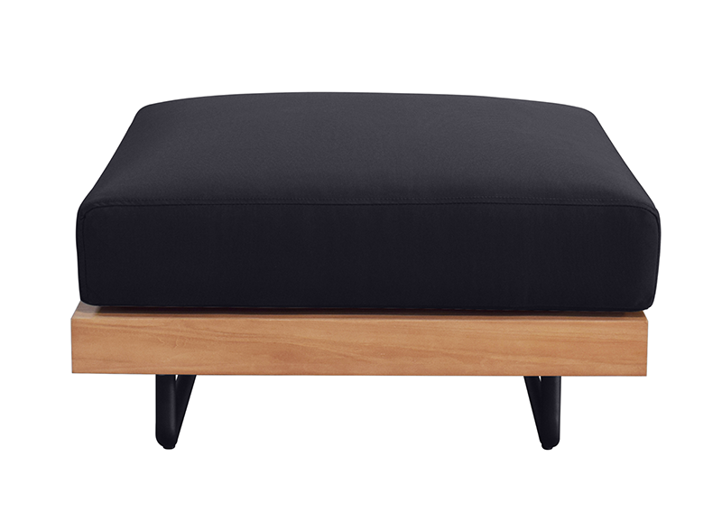

**SKU:** 1W-0066-00

## Product Summary

**Material:**Tubular Aluminum/Teak

**Finishes:**



**Cushion SKU:** C1W-0066-00 + Fabric #

**Dimensions:**27.8″ W x 27.8″ D x 7.9 H″