**Bay Arm Chair**

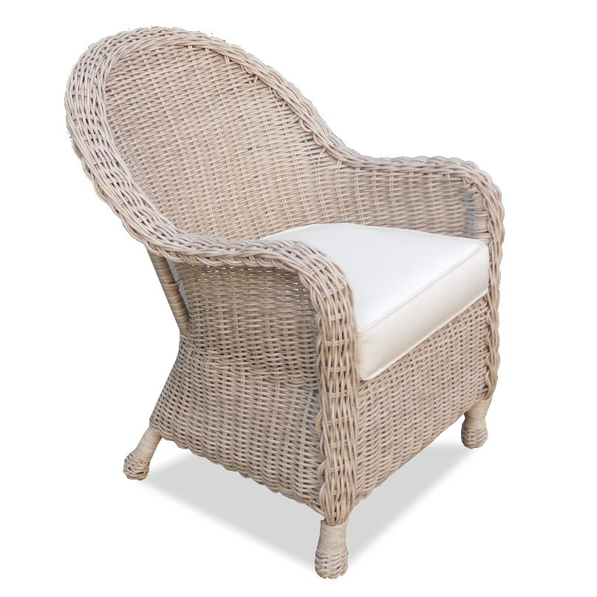

**SKU:** 1006

## Product Summary

**Material:**Resin Wicker

**Finishes:**Cocoa, Pebble Sand

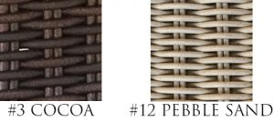

**Cushion SKU:** C8034 + Fabric #

(Bay cushions come standard **without** welt)

**Dimensions:**30″ W x 28″ D x 36″ H