**Bay Club Chair**

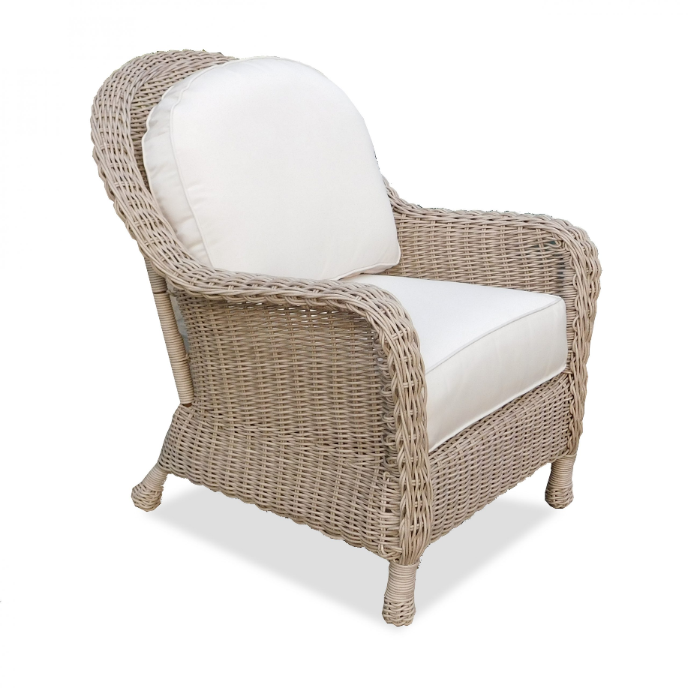

**SKU:** 1003

## Product Summary

**Material:**Resin Wicker

**Finishes:**Cocoa, Pebble Sand

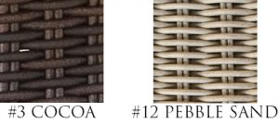

**Cushion SKU:** C8031 + Fabric #

(Bay cushions come standard without welt)

**Dimensions:**30.5″ W x 38″ D x 37″ H