**Bay Sofa**

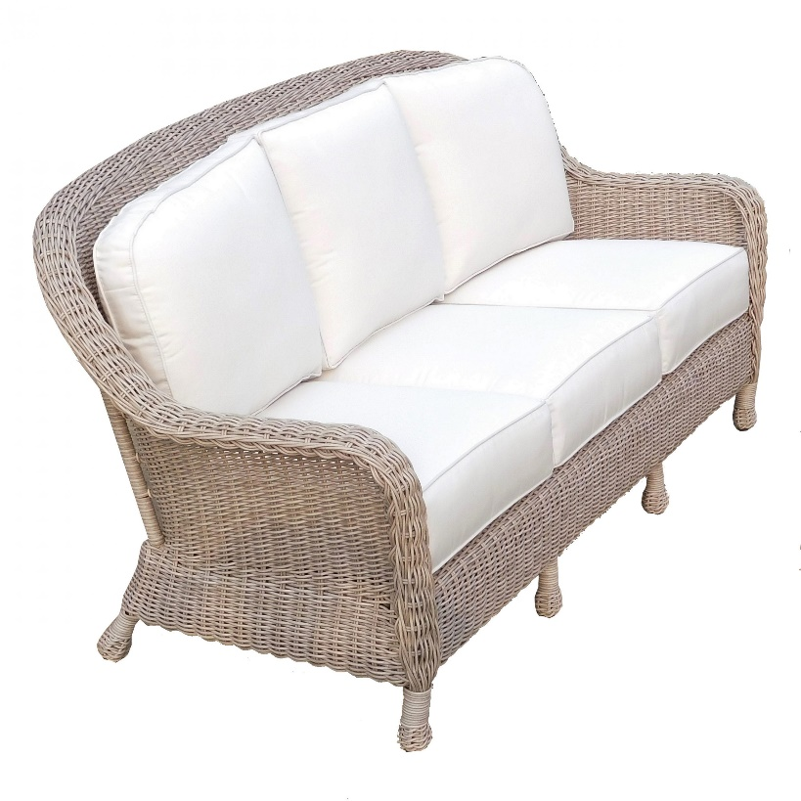

**SKU:** 1001

## Product Summary

**Material:**Resin Wicker

**Finishes:**Cocoa, Pebble Sand

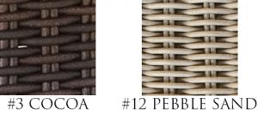

**Cushion SKU:** C8029 + Fabric #

(Bay cushions come standard **without** welt)

**Dimensions:**74.5″ W x 38″ D x 37″ H