**Belize Club Chair**

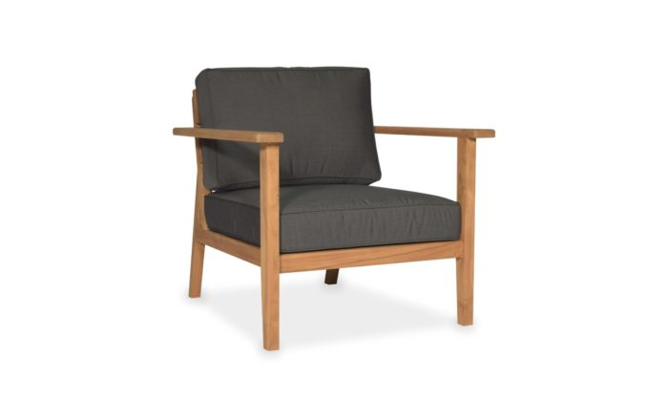

**SKU:** 1W-0001-30

## Product Summary

**Material:**Teak Wood

**Finishes:**Natural Teak



**Cushion SKU:** C1W-0001-30 + Fabric

**Dimensions:**30.3″x 30″ x 28.75″ (Seat H: 16.5″ Seat D: 24.5″ Arm H: 23.75″)