**Belize Dining Chair**

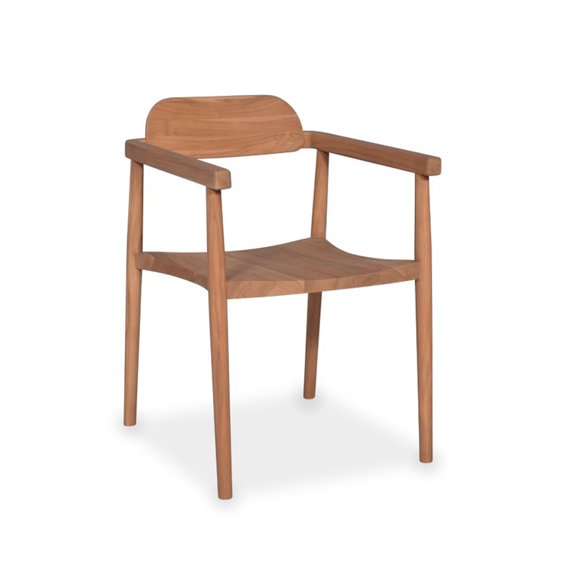

**SKU:** 1W-0003-30

## Product Summary

**Material:**Teak

**Finishes:**Natural Teak



**Dimensions:**22″ D x 24″ W x 28″ H